FLOOD
(Internal or External)

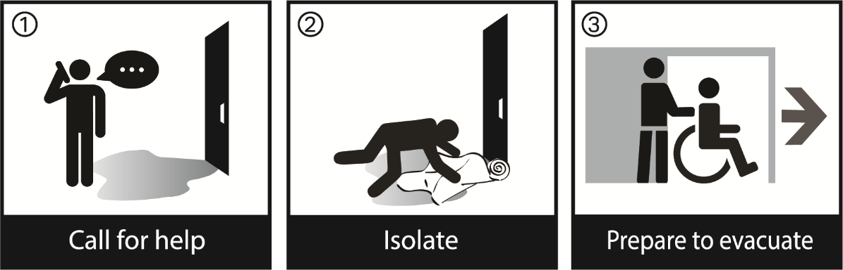

OVERVIEW
Flooding can occur whether internal (e.g., pipe break) or external (i.e., rising floodwaters from torrential rains, etc.).

Flood procedure may be activated when:
- You are notified by local authorities that your facility is located in a flood area.
- Facility staff identifies a potential internal or external flooding event.

GENERAL ACTIONS APPLICABLE TO ALL STAFF
- Move residents and staff to unaffected portions of the building.
- Move important records, equipment, etc. to unaffected portions of the building, if possible.
- When possible, move computer hard drives to the top of desks, and place resident personal articles and drawers on top of beds or dressers. A file cabinet containing important records should be moved to prevent damage.
- Where possible, build dikes and berms or take other actions to prevent the water from entering additional areas. Work with local authorities and the Office of Emergency Management.
- If an advanced warning is available, prepare residents, supplies, and staff for evacuation out of the facility, or to safe areas of the facility, if directed.
- Continue to prepare for the evacuation of the building should it become necessary.
- See Full Building Evacuation Plan.

NOTE: DO NOT ENTER ANY AREA WHERE THE WATER LEVEL IS ABOVE ELECTRICAL OUTLETS. ALSO, DO NOT TOUCH ANY ELECTRICAL EQUIPMENT WHEN STANDING IN WATER.

ADMINISTRATOR / INCIDENT COMMANDER
- Consider activating the Command Center and assigning positions to manage the incident and ensure all other guidelines of this procedure are carried out. If not, all plan actions must be accomplished by on-duty administrative staff.
- If advanced warning is available, consider census reduction of higher acuity residents.
- If life-threatening, move residents immediately.
- Areas of concern in the facility if external flooding should occur include:
  - ___________________________
  - ___________________________
  - ___________________________
- If the threat is present from internal or external flooding, direct residents and articles to be moved to higher ground, away from water pooling.
- If advised by local agencies, prepare for building evacuation. See Full Building Evacuation Plan and begin to make arrangements for transportation resources.
- If full building evacuation is to take place, set up off-site communications/command for staff and responsible parties to contact.
- Request an assessment of staff and operations through the completion of the Department Rapid Assessment Form. Direct Department Managers to complete and forward the form to the Command Center.
- Start planning Recovery:
  - Follow the “First 24 Hour Checklist” at the end of the Flood Plan.
  - For major building or utility damage, see Recovery Plan.

MAINTENANCE
- IF INTERNAL FLOODING: Immediately move to shut off or block the source of the water and shut down electrical power to areas of the building affected by or expected to be affected by internal floodwaters.
- IF EXTERNAL FLOODING: Monitor areas for exposure to electrical equipment and shut down electrical equipment if affected by rising water. Keep Command Center advised.
- Shut down elevators if water is expected to affect elevator pits or equipment rooms. Move elevators above the high-water mark. Mark and secure them.
- Work with the staff member(s) responsible for Infection Control and handling of regulated medical waste to ensure that minimal contamination occurs.
- Secure any environmental contaminates (i.e., bio-waste, chemical drums) in the area that could be flooded.
- Secure any portable oxygen cylinders in the area that could be flooded.
- Raise or move any chemicals in areas that could be flooded that may react with water to produce heat or flammable or noxious gases (CHECK THE SDS).
- Ensure any storage tanks in the area that could be flooded are either anchored securely or removed.
- Contact local vendors/contractors for clean up of contaminated silt, debris, oil, chemicals, water, mildew, etc.

NOTE: If Maintenance staff remains in the building after evacuation to shut down utilities and secure the building, ensure a communications link is established with off-site Command, or notify local Police if you cannot get through to Command.

NURSING
- Monitor staff and residents for signs and symptoms of hypothermia.
- Utilities of power, gas, water, and medical gases/air may be shut down. Follow applicable procedures.

The following is a pre-designated list of resident units and items that could be threatened by floodwaters:

PEOPLE AND ITEMS TO BE MOVED TO A SAFE AREA | LOCATION OF  SAFE AREA | RESPONSIBLE  PARTY
Resident Units / Treatment Areas
Non-resident Departments
Records
Medications
Special Medical Equipment
Other (List)

RETURN TO NORMAL OPERATIONS / RECOVERY
As floodwaters recede:
- Instruct staff to not step in pools of water where there is the danger of electrical outlets or cords in water.
- All departments will:
  - Complete the “First 24 Hours Checklist” at the end of this Flood Plan.
  - Complete the Department Rapid Assessment Form.
- Have Maintenance:
  - Survey building and utilities.
  - Re-establish communications if lost during the flooding.
  - Test water supplies (drinking).
  - Use emergency water supplies until authorities announce the water supply to the facility is potable and deemed safe for use.
- As necessary, obtain necessary clearance to reoccupy those areas which had been flooded and evacuated.
- Assess staff and department operations
- All departments, as applicable, will re-supply medical, food, equipment, and other items necessary for normal operations.
- Residents who were relocated, either within or outside the facility, will be returned when approvals have been obtained.
- Incident Commander (Administrator) should consult with the City / County Emergency Operations Center, as applicable, and issue the “All Clear.”
- Have Public Information Officer communicate with the public regarding the fact that the facility is open for business.
- Have Finance Section collect costs for disaster, as necessary.
- Develop a full report and close down Incident Command.
- Critique reports and make necessary updates to the plan.

NOTE: If the disaster resulted in any major operational building or utility damage, see Recovery Plan.

ADDITIONAL REFERENCES:
Loss of Heating System Procedure
Loss of Air Conditioning System / High Heat Procedure
Loss of Telephone / Internal Communications Procedure
Loss of Electric Service Procedure
Loss of Emergency Power Procedure
Full Building Evacuation Plan
Disaster Recovery Plan
FIRST 24 HOUR CHECKLIST

NOTE: The following actions help your staff begin the cleanup process. Professional cleaners have the equipment necessary to quickly remove large volumes of water and properly clean and treat buildings and furnishings. Professional equipment restorers bring the experience and resources to effectively clean and repair electronic equipment and get it recertified, if necessary.

BUILDING | EQUIPMENT
- Remove wet items such as carpeting, padding & ceiling tile, to exterior location.  - Use available and rented vacuum equipment to eliminate water. Also use squeegees and mops.  - Set up any available dehumidifiers (if outside temperature is >60° F).  - Open any doors and windows to help reduce humidity (if weather is appropriate).  - Use fans to help circulate air and assist drying.  - Open drawers and closet doors to enhance drying.  - Place non-staining blocks or aluminum foil under furniture legs.  - Lift draperies off carpet and suspend.  - Move photos, painting and art objects to a safe, dry location.  - Remove damp books from shelves and spread in a stable, dry environment.  - Leave the heat on if damage occurs during a cool season. Utilize air conditioning if it occurs during a warm season. | - Turn off power immediately! Do not energize wet equipment.  - Do not re-energize equipment until authorized by qualified restoration personnel or manufacturer’s technical representative.  - Open cabinet doors/side panels/covers/ chassis drawers – drain all water.  - Remove equipment to a cool, dry area after wiping down and eliminate as much moisture and contaminants as possible.  - Set up fans to move ambient air through equipment.  - Blow water out with clean compressed air (or preferably liquid nitrogen).  - Spray water displacement solvent on electronic components (such as contact cleaner, LPS 1 or alcohol/Freon mixture).  - Wipe down and dry metal surfaces as soon as possible – use protective surface treatments so slow corrosion (CRC, LPS 1).  - Follow up with professional restoration services.

RECORDING EQUIPMENT  (back-up drives) | MAGNETIC MEDIA
- Do not operate if wet or dirty.  - Clean tape transport mechanism with alcohol solvents – dry out if wet.  - Wipe off surface contamination before drive system use.  - Treat electronics as detailed above.  - Do not re-energize equipment until authorized by qualified restoration personnel or manufacturer’s technical representative.  - Follow up with professional restoration service. | - Do not use if wet or dirty.  - Clean and dry dirty tapes/disks / cassettes with alcohol-based solvents for one time data recovery.  - Send wet head disk assemblies (HDAs) to a specialist for data recovery.  - Save the data – not the media.  - Follow up with professional restoration service.
FIRST 24 HOUR CHECKLIST
Continued

SPILL RESPONSE CART AND PIPE REPAIR SUPPLIES

If not already available, assemble a spill kit/cart with emergency pipe repair supplies that can be used for quick access and use anywhere in the facility. The following list contains items to be collected as part of the response kit.

SPILL RESPONSE CART AND PIPE REPAIR SUPPLIES
- Plastic sheets to throw over & protect equipment (Make plastic sheets to cover electronic equipment readily available in the applicable areas for use by operators)  - Plastic bags to dispose of wet material  - Wet vacuums or other water removal equipment (commercial grade with effective GFIs, squeegees, mops, buckets)  - Portable pump(s) and hose  - Water displacing solvents for applying to electrical equipment (examples: contact cleaner, LPS 1)  - Preservatives for metal (examples: CRC, LPS 1)  - Towels for wiping up (assumed to be available from Housekeeping) | - Absorbent socks, to contain and absorb spills  - Alcohol for computer tapes and disks (ISA99 for purity)  - Pipe clamps to place around and stop a leak (pipe repair kit)  - Diagrams of piping systems with valve locations highlighted  - Dehumidifiers (or ready rental source)  - Boots  - Portable dikes for diverting surface water away from below-grade doorways and possible points of water entry. This would be necessary during unusually heavy rains, especially if the facility has a history of water accumulating near certain doorways, loading docks, parking ramps, etc.

HAZARDOUS MATERIAL SPILL OR LEAK / INTERNAL

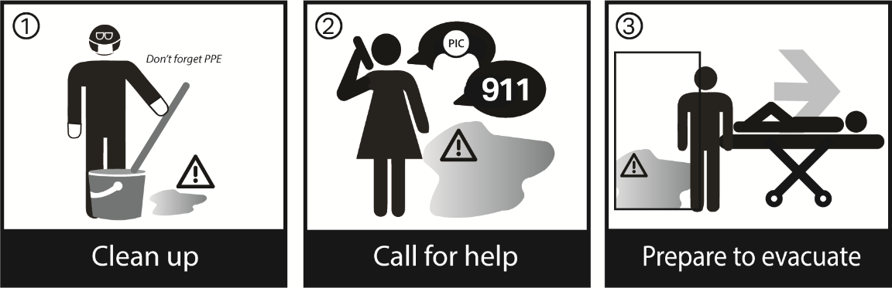

OVERVIEW
This section of the plan presents procedures to be followed in a hazardous material (chemicals such as cleaning supplies, pool chemicals, oils, solvents, fuels, etc.) spill or leak. The procedures are provided for general emergency conditions that apply to all departments.

GENERAL ACTIONS APPLICABLE TO ALL STAFF
- Maintenance and Department Heads of the affected area have the authority to take immediate corrective actions whenever a hazardous situation exists that can cause injury to residents, employees, or visitors or damage to the physical plant or operations.
- If a spill or leak is handled (cleaned up) within normal operations, there may not be a need to activate the Incident Command System or notify external Emergency Agencies.
- If the situation requires additional external assistance, call 911 and set up Incident Command.
- Take initial actions detailed in the following sections if:
      - Hazardous material is involved in fire
      - Rescue of staff or residents is required
      - Evacuation of the area is required
      - Hazardous material results in exposure of staff / residents if it spreads throughout the building
- Notify Administrator, Person in Charge, and Maintenance of all spills.
- Ensure the Safety Data Sheets (SDS) for the hazardous material are available for Maintenance and emergency responders if they have been notified when they arrive.
- Evacuate any residents, visitors, or staff from the area if not involved in the spill response.
- Department Manager or Supervisor will account for staff in a safe area.
- Ensure hazardous material is cleaned up, as detailed in this procedure.

ADMINISTRATOR / INCIDENT COMMANDER
- Consider initiating a Code ______ to manage the incident and coordinate with the Section Chiefs, ensuring all other guidelines of this procedure are carried out. If not, all actions of the plan must be accomplished by on-duty administrative staff.
- If applicable, have Maintenance shut down HVAC.
- Once the situation is under control, complete injury and incident reports as applicable.

IF A HAZARDOUS MATERIALS SPILL RESULTS IN A FIRE: RACE
- R – Remove anyone in danger and close the door.
- A – Activate the fire alarm.
- C – Contain spill and fire – Warn others to stay away.
- E – Evacuate from the immediate area of the spill or vapor release.
  - Advise Fire Department of hazards.

IF RESCUE OF PERSONNEL IS REQUIRED:
- Determine the level of hazard (reference SDS) presented by the hazardous material.
- Remove injured person(s) from the immediate area if there is no risk of personal exposure. Treat as appropriate.
- If unsafe to enter the area, secure the area, set up a physical barrier (i.e., shut door), and inform emergency responders of victim locations and hazards.
- Reference SDS and label information if available, or expert information. Contact Poison Control for first aid information, as necessary.
- Complete an official injury report for all injured parties.
- Only trained personnel/contractors will participate in clean-up operations.

IF EVACUATION OF AREA IS REQUIRED:
- Any exposed individual should be transported to the hospital. (EMS will inform the hospital Emergency Department of the exposure before the exposed individuals enter the hospital if this has not already been done. Decontamination may be necessary, depending on the type of exposure.)
- Evacuate the smoke compartment of origin.
- Second, account for staff and residents.
- Evacuate vertically and then evacuate out of the building when necessary. Follow Full Building Evacuation Plan.

SDS FORMS ARE LOCATED IN THE FOLLOWING AREAS:
- ___________________________________
- ___________________________________
- The following equipment is located in the facility’s ________ area

Absorbent | Broom
Eyewash | Water hose
Face shields | Rubber boots
Rubber gloves | Safety goggles or glasses
Shovel

HAZARDOUS MATERIAL SPILL CLEAN-UP

INCIDENTAL SPILLS

Definition
OSHA defines an incidental release as “a release of a hazardous substance which does not pose a significant safety or health hazard to employees in the immediate vicinity of the employee cleaning it up, nor does it have the potential to become an emergency within a short time frame. Incidental releases are limited in quantity, exposure potential, or toxicity and present minor safety or health hazards to employees in the immediate work area or those assigned to clean them up. An incidental spill may be safely cleaned up by employees familiar with the hazards of the chemicals with which they are working.”

For Example:
      - Small volume of one gallon or less and incidental to normal use.
      - Material identified, and hazard characteristics do not require specialized clean-up response.

Clean-up Response
- Chemical user can clean up when The Spill Does Not Involve Fire.
- IF IN DOUBT – CONTACT MAINTENANCE AND THE FIRE DEPARTMENT; DO NOT ATTEMPT CLEAN-UP.
- If possible, cover spill with linen or absorbent material to limit vapor spread.
- Notify Maintenance.
- Follow information on SDS and advice of a knowledgeable person in the spill area regarding clean-up procedures.
- Adjust anything that is allowing a leak to continue (i.e., stand up knocked over the container, adjust a leaking, liquefied gas cylinder, so it leaks gas and not liquid, close valves), if safe to do so.
- If available, use appropriate spill kits or spill equipment to stop the spread. Seal off any drains.
- Pick up any broken glass with tongs or a mechanical device. Do not use your hands!
- Report any release to appropriate agencies (see the following information).
- Dispose of hazardous material waste in a plastic bag. Label the bag with the material name. Call Housekeeping for disposal.

LARGE SPILLS / INCIDENTAL

Definition
Moderate to large volumes, or the hazards of this material require such a response. Where spill clean-up is beyond the capability for safe in-house response and/or presents possibilities for spread to other areas posing hazards to public health, safety, or the environment.

For Example:
      - Greater than 1 Liter, possibly up to several gallons
      - Hazards of material require such a response:
  - Mercury Spill, Acids, etc.

Clean-up Response

IMMEDIATE NOTIFICATION: FIRE DEPARTMENT (911)
POISON CONTROL CENTER

Large spills shall be handled by commercial emergency service providers with the required notifications to public authorities.

If you need to find local contractors to handle the clean-up of your Haz-mat situation, call_________ or call CHEMTREC at 1-800-424-9300.

If hazardous waste discharge from a facility threatens human health or the environment, or Reportable Quantities “RQ” Hazardous Substances are discharged into the environment, report this to the National Response Center at 1-800-424-8802.

Department of Energy and REAC/TS (Radiation Emergency Assistance Center /Training Site)
24-hour Emergency Phone Number: 1-865-576-1005

RETURN TO NORMAL OPERATIONS / RECOVERY
- Have Maintenance ensure all hazardous materials are cleaned up.
- Have Maintenance change necessary filters.
- Get clearance from applicable local authorities, as necessary.
- Assess facility, staff, and department operations.
- Collect costs for disaster.
- Have Department Heads restock supplies as needed.
- Develop a full report for critique and close down Incident Command.
- Critique reports and make necessary updates to the plan.

NOTE: If the disaster resulted in any major operational building or utility damage, see Disaster Recovery Plan.

ADDITIONAL REFERENCES:
Emergency Utility Shut-Off Locations
Emergency Agency Phone Numbers
Emergency Contractor/Vendor Phone Numbers
HOSTAGE TAKING

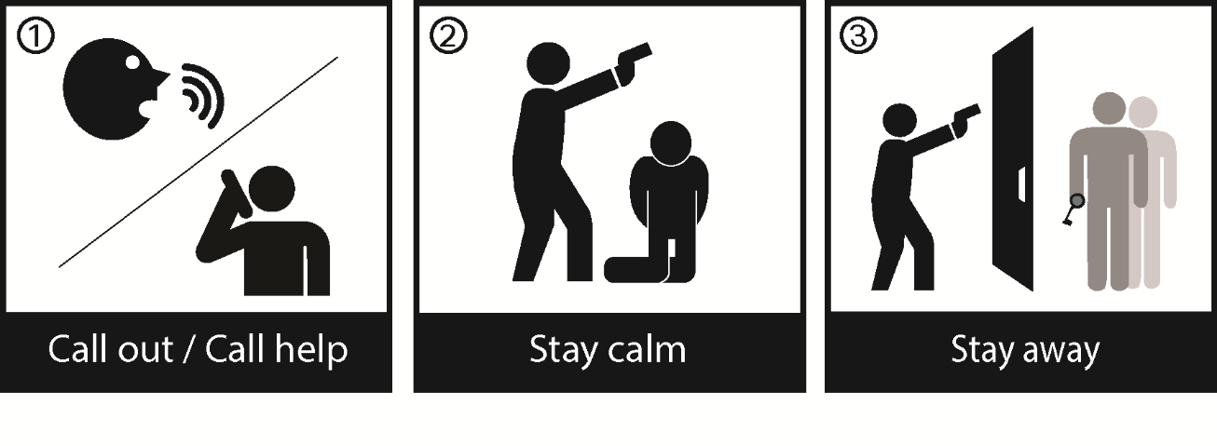

OVERVIEW
The purpose of this procedure is to assist staff members and/or visitors who are confronted by an individual who has taken hostages within the healthcare facility or its property.

SUPPORTING INFORMATION
- The facility reserves the right to inspect the contents of all packages or articles entering or being removed from the facility. Firearms and illegal weapons are prohibited from being on the premises. Weapons, dangerous devices, and illegal or unsafe items will be turned over to local law enforcement authorities.
- Weapons are not permitted on the facility’s property, except for persons who are professionally exempted or authorized by law to carry a weapon in the performance of their duties, such as City, County, State, or Federal law enforcement officers.

GENERAL ACTIONS APPLICABLE TO ALL STAFF
- If threatened, call out to other staff for assistance.
- If you witness a hostage situation at the facility, call 911 and give the following information:
  - Location of incident (building, floor, and room)
  - The number of suspects, hostages, and names, if known
  - Type of weapon(s) involved
  - Time of occurrence
  - Injuries sustained (if any)
  - Announced intention and/or demands of hostage-takers
  - Demeanor of hostage-takers (calm, agitated, angry, violent)
  - Characteristics of hostage scenario (drugs, alcohol, weapons, or explosive devices involved)
  - Scope of security perimeters established around the location of the hostage situation
- Contact ______________________ and Security/Maintenance via radio/phone.
- Provide safety to others. DO NOT FURTHER ENDANGER ANYONE.
- Contain the incident by preventing people from entering the area until Police arrive.
- If there is ANY sign of actual danger/violence, DO NOT attempt any direct contact type of action.
- If You Are Taken Hostage, follow these basic survival tips:
  - Remain calm. Be respectful. Be prepared to wait.
  - Make no unnecessary movements that might cause the individual to harm you.
  - Discard anything that may label you as a person of importance or someone the captor(s) may fear (e.g., pager, ID badge).
  - Treat the hostage taker(s) with respect.
  - Do not speak unless you are specifically addressed or questioned.
  - Do not volunteer information or make suggestions.
  - Do not attempt to negotiate with the hostage taker(s).
  - Cooperate and follow instructions.
  - Be prepared to communicate with Police on the phone. Give as much information as possible to identify suspects discreetly. Carefully consider any attempt to escape. A foiled attempt can be extremely dangerous for you and other hostages.
  - When rescue comes, follow Police instructions exactly. Mentally note as many characteristics of the hostage taker(s) as possible (sex, age, height, weight, color of eyes/hair/skin, scars, etc.) NOTE: You may be handcuffed or secured until all suspects are identified.
  - Refrain from speaking to other hostages.

ALL FACILITY STAFF NOT IN THE IMMEDIATE AREA OF THREAT
- DO NOT GO TO THE AREA OF THE INCIDENT. THIS IS AN EXTREMELY DANGEROUS AND SENSITIVE SITUATION THAT SHOULD ONLY BE HANDLED BY TRAINED AUTHORITIES.
- Staff near the area should evacuate, if possible, or seek cover / protection and warn others in the area of the situation.
      - Staff not in the area should take cover behind locked doors, if possible, and avoid the area. Also avoid windows facing the location and control entrances and exits to their units. Secure doors and stand by for further instructions.
      - Department Heads should report to their respective units and assume control of their area with regard to the above procedures.

ADMINISTRATOR / INCIDENT COMMANDER
- Activate the Command Center by notifying Section Chiefs and Command Center personnel by phone or pager notification and indicating a Code Alert. Manage the incident, and through the Section Chiefs, ensure all other guidelines of this procedure are carried out.
- Immediate life safety actions have probably been activated in the area of threat.
- Decide on a course of action to be taken pending arrival of Police. The facility should be closed to all except bona fide calls from staff, physicians, resident family members or other authentic sources.
- If necessary, call the following shift Nursing/Resident Care staff personnel and other departments and inform them of the situation. All personnel, except those on duty, should be instructed to remain out of the facility until further notice. Maintenance (staff assigned security roles) should be directed to report immediately to assist in dealing with the situation.
- Instruct Maintenance to prepare for a fire alert and to have personnel standing by to shut off electrical power, natural gas, or any source of ignition. It is imperative that all facility personnel cooperate fully with the Police and Fire Departments.
- At the direction of the Police, an “All Clear” will be announced. All affected personnel will be contacted immediately for debriefing purposes.
- Department Heads and Managers:
- All managers should report to their respective units and assume control of their area with regard to the above procedures.
- Secure and search their area. Report results to the Command Center.
- Endeavor to make sure all residents and staff are present or accounted for and advise the Command Center of any discrepancies.
- They will be briefed about the situation and receive instruction and assignments from the Administrator or person in charge of the incident.
- Pass briefing information along to all staff.
- Public / Community Relations:
- All media coverage is to be directed by the Administrator or Incident Commander. Staff must NOT give out any information to the media. Media representatives may be quite assertive, and some may not display official identification. The incident should not be discussed openly among the staff and is extremely confidential. The Police will request that any and all official statements of the facility be discussed with the designated Police representative before being released.

SWITCHBOARD
- Notify Police via 911 if not already notified. Give them any information that is known about the situation and advise if there is an approach out of sight of the area of the threat.
- Notify Maintenance via radio.
- Contact the Administrator or highest-ranking person on-site.

SECURITY / MAINTENANCE / STAFF ASSIGNED SECURITY ROLES
- Assess the situation.
- If you determine or suspect that a person with no official business or medically related reason for being in the facility is, in fact, circulating within the premises, they should be challenged. The person should be escorted out of the building as discreetly as possible, on the basis that they have no reason for being in any part of the facility except the Reception area. If the person objects, back off and try to isolate them. Notify the Police Department.
- Take control until Police arrive. Provide logistical and manpower support.
- Initiate a Building Lockdown, as necessary.
- Secure the immediate area, if possible, by removing all residents and personnel.
- Secure doors, if appropriate, to isolate incidents.
- Identify phone extensions in the closest proximity of hostage-takers.
- Identify door locking systems and keys controlling ingress and egress of the secured perimeter.
- Identify surveillance and recording systems monitoring the area of suspect and hostage and/or points of ingress and egress from the secured perimeter.
- All telephone extensions to the area should be identified and secured.
- Gather and report information to responding authorities.
- Ensure all delivery/vendor vehicles remain on facility grounds until searched by the Police Department.
- Provide floor plans of building to Police, including HVAC plans.
- Control elevator to the affected area(s).
- Place staff at strategic safe points to guide unauthorized people away from the danger area.
- Special precautions should be taken to protect the oxygen storage area. The generator, boiler room, and food storage shall also be guarded against actions by intruders.

RETURN TO NORMAL OPERATIONS / RECOVERY
When all threat has been eliminated:
- Notify the Police if they have not already been called.
- Provide security for any residents or staff threatened by the situation until appropriate responsible parties take over.
- Keep Crime Scene Secure:
  - Isolate and protect the scene and evidence. DO NOT ALTER THE SCENE OR TRY TO INVESTIGATE the crime or incident. The Police will advise you of the actions/procedures to follow.
  - Do not allow witnesses to leave before Police arrive.
  - Do not allow witnesses to “compare notes.”
- Document everything while still fresh in your mind (Police, facility legal counsel, etc., may need this information as soon as possible for the follow-up and ongoing investigation).
- Nursing/Resident Care staff shall assess, treat and calm persons involved in the incident, completing any incident reports, as necessary. Debriefing should take place, as necessary, through the Employee Assistance Program.
- All persons actually involved in the incident should remain available to talk to the Police upon their arrival.
- Communicate to the public that the facility is open for business, if necessary.
- Post-incident stress debriefing should be made available to those involved in the incident.
- Have Finance Section collect costs for disaster, if applicable.
- Develop a full report for critique.
- Close down Incident Command.
- Critique reports and make necessary updates to the plan.

ADDITIONAL REFERENCES:
Building Lockdown Procedure – Section B
AGGRESSIVE OR VIOLENT BEHAVIOR GUIDE

GENERAL
If you recognize a situation where someone is displaying aggressive or violent behavior toward yourself or others:

- Examine your surrounding environment:
  - Look for a quick exit if the situation escalates to violence.
  - Don’t back yourself into a corner where you can’t get away.
  - Don’t turn your back on the aggressor.
  - Is there anything you could use to place between you and the aggressor (i.e., chair, desk, or furniture) if the situation escalates to violence?
  - Try to maintain a distance between you and the aggressor (i.e., don’t lean in too closely if you talk with them).
  - If the situation escalates into violence, immediately summon assistance from other staff and request the Police be notified, as appropriate.
- Apply de-escalating techniques:
  - Listen to the person displaying aggressive behavior. Many people are upset because they are hurting and believe that no one cares. Listening to them and displaying empathy may help calm them down.
  - Ask them what the problem is? What is the answer to that problem, i.e., what actions do they want to happen today?
  - Empathize. Reflect back to them the fact that you are listening and that you understand their feelings. Acknowledge their point of view (you don’t have to agree with it, just understand how it might make them feel).
  - Lower your voice and speak calmly. When aggressive people are loud or shouting, lowering your voice may make them lower theirs just so they can hear you, or it may make them realize they are using excessive volume in their voice.
  - Encourage the person to physically sit down and talk with you. Aggressive behavior is more likely to escalate to violence if a person is standing up rather than sitting.
  - Assume a non-threatening posture (i.e., don’t speak using wide sweeping motions with your hands or arms).
- If possible, help the aggressor achieve the outcome they desire:
  - Can you help this person achieve their desired outcome?
  - Can you direct them to someone else who can? If so, physically contact that person via phone and ensure that the issue is being taken care of (i.e., don’t just walk away).

HURRICANE

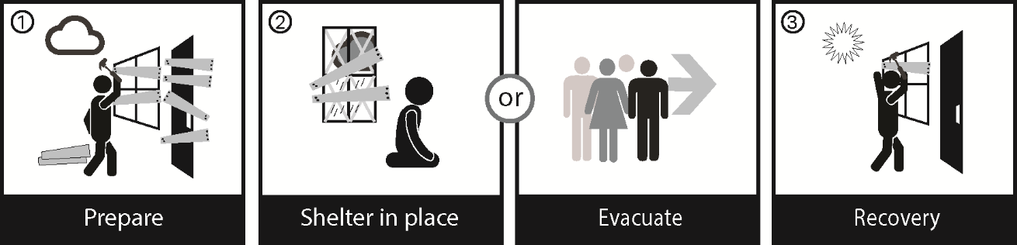

OVERVIEW
One of healthcare’s greatest threats is that of a tropical storm or hurricane. The typical season is June 1 – November 30, with the greatest number of hurricanes occurring in August, September, and early October.

TERMINOLOGY
Warnings and watches are two levels of an alert issued by the National Weather Service forecasting the imminent approach of a tropical cyclone or tropical storm of hurricane intensity.

TROPICAL STORM WATCH: Issued when tropical storm conditions, including winds from 39 to 73 mph, pose a possible threat to a specified coastal area within 36 hours.

HURRICANE WATCH: A hurricane watch is issued for a specified area for which a hurricane or hurricane-related hazard is a possible threat within 36 hours.

HURRICANE WARNING: A hurricane warning is issued when a hurricane with sustained winds of 74 mph or higher is expected in a specified coastal area in 24 hours or less.

STORM CATEGORIES
CATEGORY | WIND | APPROX. STORM SURGE | EXPECTED DAMAGE
Tropical Storm | 39-73 mph |  | Flooding Possible
Hurricane I | 74-95 mph | 4-5 feet | Minimal
Hurricane II | 96-110 mph | 6-8 feet | Moderate
Hurricane III | 111-130 mph | 9-12 feet | Extensive
Hurricane IV | 131-155 mph | 13-18 feet | Extreme
Hurricane V | >156 mph | > 18 feet | Catastrophic

- If a hurricane does impact the area, it may result in disruption to the provision of supplies and services. All departments should always be prepared for a minimum of a 3-5 day isolation period, assuming no supplies coming into the facility from outside sources. When there is an advanced warning, such as during the hurricane season, departments should “stock up” for the possibility of a 5-7 day isolation period, if deemed necessary.
- The facility will try to protect residents, staff, and their families, when appropriate, within the facility. It may become necessary to evacuate. This decision will be made by the Administration/Incident Commander at the time of the event notification in coordination with local emergency officials.
- Continuous informational updates will be provided to residents through briefings provided by designated leadership staff.

GENERAL ACTIONS TO BE TAKEN BEFORE THE STORM

ANNUAL PREPARATION
- Annually, Department Directors/Managers should prepare for the upcoming hurricane season by reviewing with their employees preparedness procedures.
  - General preparedness includes:
    - Conduct annual reviews of Emergency Procedures and department-specific plans, including the updating of staff phone lists.
    - Review insurance plans.
    - Review responsibilities with management and staff.
    - Order, store, and/or pre-position for a 7-day supply of food, water, and other logistical/medical supplies, if deemed necessary. Top off all fuel tanks, including the generator and vehicles, as practical.
    - Confirm evacuation transportation agreements and evacuation routes.
    - Confirm evacuation agreements with other healthcare nursing facilities that have agreed to accept evacuated residents.
    - Confirm/review agreements, if any, with local Police, National Guard, Security Contractors, etc., regarding the protection of staff, buildings, or the entire campus.
    - Review procedures and supplies needed for physical building preparations, including agreements for backup generators and fuel supplies.
    - Test emergency communications (radios, cell phones, etc.).
      - During the hurricane season, the facility will monitor local weather forecasts and the weather alert radio when severe weather is anticipated.

PREPARATION FOR THE HURRICANE SEASON

POSITION RESPONSIBLE TO ACCOMPLISH SPECIFIC ACTIONS | ACTIONS TO BE TAKEN  IN ORDER OF IMPORTANCE | Check when completed
ADMINISTRATION, DEPARTMENT DIRECTORS AND MANAGERS | Review emergency procedures, supplies, and equipment on a regular basis to ensure information is up to date, supplies are at adequate levels, and equipment used for disaster/emergency incidents is in good operating condition.
 | Review responsibilities with your staff.
 | Order, store, and/or pre-position for a 5-7 day supply of food, water, and other logistical / medical supplies, if necessary.
 | Confirm backup vendors/services for Pharmacy, Medical Supplies, etc.
 | Top off all fuel tanks, including the generator and vehicles, as practical.
 | Review internal evacuation procedures for residents.
 | Review Insurance Plans.
 | Review emergency sanitary waste and biohazard storage and disposal procedures.
 | Establish discharge review procedures.
 | Review procedures and supplies needed for physical building preparations. This includes agreements for backup generators.
 | Test emergency communications.
 | Monitor National Weather Service.
 | Review agreements with Police and National Guard regarding protection of building and staff, if applicable.

HURRICANE WATCH

ADMINISTRATOR / INCIDENT COMMANDER
- Implement a “Hurricane Watch Alert” whenever a reasonable probability exists that your area is in the path of a potential hurricane. A Hurricane Watch is issued by the National Weather Service. A watch indicates hurricane conditions are a real possibility, usually within 24-36 hours, but it does not mean that it will happen. When the watch is issued, each department and Incident Command position should address the following and continue to monitor NWS advisories.
- Activate the Incident Command System, as necessary, and assemble the Command Center staff. The Command Center staff will assess the situation, review plans, and take preventive measures.
  - Keep staff advised of hurricane development.
  - Confirm the following:
    - The facility is not a general population shelter, although some community members may be sheltered at the discretion of the Incident Commander.
    - Determine the location of community shelters and/or evacuation pickup sites (if any). It is helpful to have the information available for staff and persons who may call the facility.
- Determine the need to order cots and other supplies and equipment before the storm.
- Determine the need to cancel non-essential services and activities based on storm predictions. This may include transportation, doctor runs, etc. Update residents regarding facility preparations through regular resident briefings.
- The facility will go under a hurricane watch as a Tropical Storm or Hurricane enters the region. If it is projected to possibly result in a Category 4 storm, and your facility is in the projected path of landfall, consider:
  - Restricting admissions, limiting access to visitors and family members.
  - Discharging residents (as selected by clinical staff).
  - Evacuating high acuity and Dialysis residents.
  - Directing resident relocation to safe areas in the facility.

NOTE: If contemplating Evacuation, refer to the Full Building Evacuation Plan.
All evacuation procedures must be completed before the onset of tropical/hurricane storm winds in the area. The facility must determine how long it will take to complete a full-scale evacuation. The amount of time it takes to evacuate the facility, then travel to the sheltering facility should be multiplied by x3 to account for evacuation traffic. Given the differences in storm tracks and speed, you must calculate and estimate this to the best of your ability.

- Test and inventory emergency communications:
  - Facility cellular phones
  - Facility pagers
  - Portable radios
- Have Public Information Officer advise:
  - Public, residents, and family members of facility status throughout the storm
  - Community Sheltering information (obtain through the Safety/Security/Liaison Officer), stressing that the facility is not a public shelter
- Determine if any residents from other areas of the campus will be evacuated into the main building. Refer to Influx of People procedures if evacuees will be sheltered in the main building.
- Have Department Directors / Managers follow their department-specific tasks, as well as the following general guidelines:
- Be prepared to remain in the facility for the duration of the hurricane emergency should a hurricane warning alert be implemented.
        - Exceptions will be determined on a case-by-case basis.
        - Confirm staffing needs and implement Staff Recall Plan: Disasters have shown that it may become impossible for staff to return to the facility after the hurricane makes landfall. Staffing needs will be supplied as necessary and available from the Labor Pool, which will be coordinated by the Labor Pool Unit Leader.
- Check emergency supplies such as food, water, flashlights & batteries, etc.
- Review Hurricane Plan, including department-specific tasks, where applicable, with staff. For departments and supplies subject to flooding, start relocations as applicable.
- Confirm and designate sheltering areas for staff and their family members, if authorized by the Incident Commander. Send an email reminding staff and families of what can / cannot be brought into facility shelters:

Items to Bring | Do Not Bring
Sleeping bag, blanket, pillow | Alcoholic beverages
Personal toiletries and a towel | Firearms
Change of clothing | Flammable or flame producing items
Prescription and Over the Counter meds for 3-5 days | TVs/Radios, DVD players, or Laptops – Unless battery operated
Nonperishable food items to last for 3-5 days, per shelteree | Open food or food requiring refrigeration
Bottled water (1 gallon per shelteree per day) | Other electrical-powered appliances (hairdryers, etc.)
Flashlight with extra batteries | Other:

- Check on-hand supplies and inventories. Request deliveries for inadequate levels. Ensure appropriate supplies for 3-5 days. Consider conservation and substitution plans.

NURSING
- Analyze staffing needs for the next 3-5 days.
- Check department inventories and stock up for 5 days. Report results to Command Center.
- Review charts from Resident Care Units to coordinate feasible discharges with the attending physician.
- Note family / responsible party contact numbers
- Prepare discharge instructions and supplies
- With the possibility of lower staffing, predetermine what resident care changes could be reduced or eliminated.
- If Incident Command directs (based on storm size and tracking), start:
- Early discharging and/or evacuation of High Acuity residents
- Relocation of residents to safer areas in the facility
- Moving residents from high wind exposure rooms to corridors
- Drawing curtains in resident rooms to lessen anxiety
- Moving residents as far away from windows as possible
- Covering windows with blankets to protect residents from flying glass
- Provide an updated resident census to the Command Center as requested. Update as resident census changes.

HOUSEKEEPING
- Analyze staffing needs for the next 3-5 days.
- Check department inventories and stock up for 5 days. Report results to Command Center.
- Contact contractor for garbage, sewage, and bio-hazardous waste pick-up prior to the storm.
- Review plans to manage garbage and bio-hazardous waste during storms when pick-up is not possible.
- Request a 5-day supply of linen supplies, as available.
- Secure a 5-day supply of:
- Red bags
- Trash bags
- Gallon size zip-lock bags

FINANCE
- Analyze staffing needs for the next 3-5 days.
- Advise each department to track staff hours and extra supplies used using tracking forms in the Incident Command System section.
- Ensure your department can financially support all departments as they acquire supplies and services.
- Make arrangements to secure cash in the event the storm forces banks and ATMs to close. Cash will be needed to make necessary purchases and help staff in the event they cannot get or cash their paychecks.

DINING SERVICES
- Analyze staffing needs for the next 3-5 days.
- Check department inventories and stock up for 5 days. Report results to Command Center.
- Implement procedures to receive food/service orders with system vendors.
- Review rationing and conservation procedures, as well as emergency non-cooking menus. Inventory available food, water, and other supplies and try to estimate the number of meals that can be served taking into consideration extra staff in the facility and any family members being sheltered.
- Drinking water supply for resident and staff meal service only.

SOCIAL SERVICES
- Analyze staffing needs for the next 3-5 days.
- Check department inventories and stock up for 5 days. Report results to Command Center.
- Contact responsible parties for pick-up of discharged residents.

MAINTENANCE
- Analyze staffing needs for the next 3-5 days.
- Check department inventories and stock up for 5 days. Report results to Command Center.
- Start the pre-planned boarding of windows and, where applicable, flood prevention procedures and/or sand bagging of doors.
NOTE: Bracing behind doors takes the pressure off the latches. This is especially true for double doors with pins at the top and bottom.
- Check roof drains to ensure they are clear, and remove any debris from the roof.
- Check the patio area to ensure the furniture and other articles have been removed.
- Secure appropriate objects outside:
  - Eliminate / Secure loose debris and trash cans
  - Remove / lay down antennas and communication dishes
- Top off generator and vehicle fuel tanks. Confirm fuel delivery from sources out of the region.
- Review agreements for backup generators and their connection to your building, should the need arise. See Loss of Electric procedures.
- Attain gasoline powered generator and fill safety cans of gas, if applicable.
- Attain portable air conditioning units, if applicable.
- Attain 50-100 feet commercial grade extension cords, if necessary.
- Attain flashlights and batteries to last for 5 days.
- Attain wet vacuums, if necessary.

SECURITY
- Analyze staffing needs for the next 3-5 days.
- Check department inventories and stock up for 5 days. Report results to Command Center.
- Limit access to facility grounds to essential traffic only.
- If resident evacuation is being planned, set up a vehicle staging area for evacuated resident pick-up. Refer to the Full Building Evacuation Plan.
- Secure parking for physicians and staff. An off-site parking plan may have to be activated. Refer to the Loss of Parking procedures.
- Post Staff at Main Entrance doors to allow discharged residents to depart.
- Place directional signage on entrances to guide people to the correct entrance.
HURRICANE “WATCH”

POSITION RESPONSIBLE TO ACCOMPLISH SPECIFIC ACTIONS | ACTIONS TO BE TAKEN  IN ORDER OF IMPORTANCE | Check when completed
ADMINISTRATION, DEPARTMENT DIRECTORS AND MANAGERS | Activate Incident Command Center and assign positions.
 | Establish liaison (communications) with City / State Emergency Operations Center, and other Healthcare facilities.
 | Consider starting evacuation of selected residents, if deemed necessary.
 | Test and inventory communications.
 | Advise local health department of facility status.
 | Ensure 5-7 days of supplies.
 | If items, articles, records, or equipment is subject to flooding, move to a safe location.
 | Confirm shelter plan for staff and families, if deemed necessary.
 | Call in staff, as necessary.
 | Complete department-specific plans.
 | Arrange for garbage and bio-hazardous waste pick-up before storm. Review how to manage garbage and bio-hazardous waste during storm.
 | Ensure food and liquid supplies for 5-7 days.
 | Start pre-planned boarding and/or bracing of windows and doors, if applicable.
 | Secure outside items, including antennas and furniture/canopies.
 | Prepare portable units (air conditioners, etc.) and generators for power loss.
 | Monitor National Weather Service.
 | Limit access to facility grounds and entrance.

HURRICANE WARNING

A hurricane warning is issued when there is a high probability that the immediate area may be at or near the storm’s landfall. A hurricane warning is normally issued 24 hours before the storm’s anticipated landfall.

Once the warning is issued, all necessary precautions that were initiated with the hurricane watch should be completed. Residents should be relocated to safer areas within the facility, or evacuated out of the facility, depending on the pre-plan for your specific facility.

ADMINISTRATOR / INCIDENT COMMANDER
- Consider activating the Command Center and assigning positions to manage the incident and ensure all other guidelines of this procedure are carried out. If not, all actions of the plan must be accomplished by on-duty administrative staff.
- Command Center staff should be given the NWS’s landfall probability predictions. The team reviews hurricane preparations, resident reduction and evacuation, identified shortfalls, staffing problems, staff call-back, etc. The following types of actions and decisions are addressed and/or implemented by the team:
- If you have not already activated resident movement, make decisions on the following:
  - Relocate residents to safer areas within the facility
  - Consider “Early Discharge” for appropriate residents
  - Evacuate pre-selected high acuity level residents and Dialysis residents
  - Evacuate all residents – Refer to Full Building Evacuation Plan.

SAFETY/SECURITY/LIAISON OFFICER
- Update communications with:
  - Local Emergency Operations Center
  - Keep Command Center staff advised of hurricane development.
  - Confirm the following:
    - The facility is not a general population shelter unless authorized by the Incident Commander at the time of the event
    - Location of community shelters and/or evacuation pickup sites (if any)
      - Test and inventory emergency communications:
    - Facility cellular phones
    - Facility pagers
    - Portable radios

SECURITY / MAINTENANCE
- Lock down the facility, with the exception of the Main Entrance.
- Complete boarding and Flooding Prevention measures (i.e., sandbagging) as outlined under Hurricane Watch.
- As landfall draws near, consider shutdown of electrical services and elevators subject to flooding. Keep off until dry. Move elevators to Second Floor or higher.

NURSING
- Check emergency supplies in each resident care area, including, but not limited to: flashlights & batteries, food, water, linens, medical and other supplies.
- Ensure sufficient supplies of resident medications for 5-7 days. As necessary, contact the pharmacy and order medication refills and stock items.
- Provide current resident census to the Command Center, and update as necessary.
- As requested, provide a list of higher acuity residents who may need to be transferred to a higher level of care.
- Ensure all residents have identification bracelets in place.
- Distribute oxygen tanks to resident care areas, as applicable.
- Complete or direct and assist in resident relocation and evacuation, when advised by the Command Center. Refer to the Full Building Evacuation Plan.
- Close windows, shades, and drapes.
- Fill bathtubs and all available containers with water for bathing and toilet use.
- Place all loose items and materials in closets and ensure doors are closed and latched.

FINANCE
- Ensure sufficient cash is accessible to key department heads. They should have sufficient cash resources to perform their necessary functions during the course of the disaster. The storm may shut down banks, ATMs, and credit card machines. Cash may be needed to make necessary purchases and help staff if they cannot cash their paychecks.
- If time allows, additional ATM and facility credit cards should be ordered so that multiple authorized signers would have access to purchasing in this manner. At a minimum, increased credit limits should be requested to ensure the availability of credit throughout the disaster. A list should always be maintained reflecting all individuals with cards, and purchases should be monitored after the fact. This is a good source of documentation for filing insurance claims and requests for reimbursements.
- As you may require the ability to process checks to acquire supplies or pay employees after a disaster, it is necessary to ensure that an adequate supply of checks is available on all bank accounts, maintained in a secure location.
- In order to preserve important financial history and support claims for insurance, tax, and reimbursement claims, it is necessary to secure historical records.

SOCIAL SERVICES
- Contact responsible parties of residents who have been approved for discharge and pick-up, if not already done.
- Contact out of state resident family members and reassure. Request phone calls are held until after the storm subsides.
HURRICANE “WARNING”

POSITION RESPONSIBLE TO ACCOMPLISH SPECIFIC ACTIONS | ACTIONS TO BE TAKEN  IN ORDER OF IMPORTANCE | Check when completed
ADMINISTRATION, DEPARTMENT DIRECTORS AND MANAGERS | Assemble Incident Command Team. Review landfall probability and facility preparation.
Request assistance from local/state emergency agencies:
- When your operations are overwhelmed
- Assistance with evacuation is needed
- Assistance with determining receiving facilities
- Assistance with transportation resources
- Assistance with supplies
 | Update all communications.
 | Keep Department Managers advised of hurricane development.
 | Complete or activate resident movement.
Complete and/or Activate:
- Supply and conservation plans
- Staff recall
 | Complete boarding of windows and doors, and sand-bagging operations.
 | Shut down electrical machinery and appliances subject to flooding.
 | Monitor National Weather Service.
 | Close windows, shades, and drapes. Fill bathtubs with water. Place loose items in closets.
 | Lock down facility.
 | Preparations should be made to increase credit limits with all suppliers of goods and services. Additional vendors should be contacted to allow for the contingency of availability.
 | Ensure sufficient cash is accessible to key department heads.
 | If time allows, additional ATM and facility credit cards should be ordered. At a minimum, increased credit limits should be requested.

LANDFALL

ADMINISTRATOR / INCIDENT COMMANDER
- Emergency actions are coordinated by the Command Center to counter adverse conditions resulting from the hurricane’s impact. Staff members must remain flexible and prepared to respond decisively during this difficult and unpredictable period. In preparation for landfall, be ready to move residents to the safest available place, such as hallways.
- Instruct staff not to go outside of the building. After the first part of the storm passes, there may be a lull in the storm, but the rest of the storm usually follows shortly after the first impact. Monitor the local media on the radio to await the “All Clear.”
- In conjunction with local, state, and federal agencies, will determine if there is a need for a full or partial evacuation of the facility.
- The decision to evacuate after landfall will be based on the building’s ability to function. Refer to Recovery Plan.
- Evacuations before landfall are selective (i.e., high acuity residents). After the hurricane passes, the priority of resident evacuation may change.
  - What utilities are lost?
  - What part of the building is damaged?
  - What facility services are not operating?
  - Can we control the evacuation, or must we move many residents quickly? If we must evacuate many residents quickly, the lowest acuity residents are evacuated first.
- Transportation for the resident will be arranged through your contracted transportation vendor and/or ambulance provider.
- When determined to be necessary (evacuation is a strong possibility based on predictions of the storm), the facility should contact a truck rental company in their immediate area to move selected equipment and files. (Depending upon the location of the sheltering facility, transport could be a very short or quite lengthy trip. Prepare residents, staff, and transport vehicles accordingly.)
- When the facility is ready to evacuate, follow the Full Building Evacuation Plan.
- Modes of transportation that may be used:
  - Fixed-wing aircraft and/or helicopter
  - Ambulances – Advanced or Basic Life Support
  - Vans / buses
  - Private vehicles
- Nursing Staff will likely be required to accompany residents during transport and may be asked to care for residents by the receiving facility.
- The Command Center will keep staff apprised of key information in order to reduce anxiety and assure everyone is working with the same level of information. The Command Center will provide communication to residents and families.
LANDFALL

POSITION RESPONSIBLE TO ACCOMPLISH SPECIFIC ACTIONS | ACTIONS TO BE TAKEN  IN ORDER OF IMPORTANCE | Check when completed
ADMINISTRATION, DEPARTMENT DIRECTORS AND MANAGERS | Once residents are secure as possible, go to a safe place.
 | Evaluate residents for medical needs. Report results to the Command Center.
 | Evaluate the ability of department operations to continue. Report results to the Command Center.
 | Evaluate the physical building and utilities.
 | Monitor the National Weather Service.
Make decision to evacuate or recover-in-place.
See Full Building Evacuation.
 | Develop Recovery Plan.
 | Monitor the National Weather Service.

RETURN TO NORMAL OPERATIONS / RECOVERY

All Recovery Planning and guidelines will be developed in the Command Center:

- Ensure staff do not step in pools of water where there is the danger of loose or dangling electrical wires.
- Post-storm, residents will be moved back into rooms, if possible. Employees will work in shifts to be available to relieve one another.
- Command Center will oversee the labor pool of returning Employees and assign them accordingly.
- All departments, as applicable, will re-supply medical, food, equipment, and other items necessary for normal operations.
- Plan and conduct other appropriate actions deemed necessary to restore the facility to normal operations.
- Consult with the City/State Emergency Operations Center and issue the “All Clear.”
- Have the Finance Section capture costs for reimbursement.
- Develop a full report for critique.
- Close down Incident Command.
- Critique reports and make necessary Plan updates.
- Maintenance:
  - Survey building and utilities.
  - Re-establish communications.
  - Test water supplies.
  - Use emergency supplies of water until authorities announce the water is potable.
  - Remove boards from windows as soon as possible to reduce the growth of mold and mildew.

ADDITIONAL REFERENCES:
Section D – Full Building Evacuation Plan
LOSS OF AIR CONDITIONING / HIGH HEAT

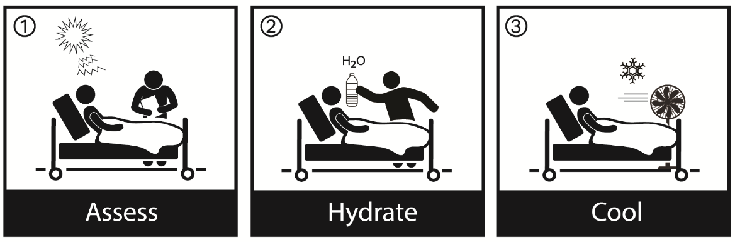

OVERVIEW
A high temperature/heat situation can be a true emergency, particularly for an elderly population. The ability to regain power, access portable air conditioning units, or other mitigating efforts should be considered at the onset of the situation. Partial or full building evacuation may be required depending on weather conditions and expected duration.

GENERAL ACTIONS APPLICABLE TO ALL STAFF
- Use fans and portable air conditioning units, if available. Notify staff members responsible for Infection Control.
- Keep blinds, curtains, drapes, etc. closed in areas of the building that receive direct sunlight.
- Open doors and windows, as necessary, to take advantage of available breezes.
- Avoid activities that may excite residents or require physical exertion.
- Keep residents out of direct sunlight.
- Turn off lights as well as other heat-producing appliances whenever possible.
- Provide plenty of liquids for residents and staff.
- Monitor vital signs of residents and staff.

ADMINISTRATOR / INCIDENT COMMANDER
- Activate the Command Center by notifying the Section Chiefs and Command Center personnel by phone or pager notification and indicating a Code Alert, as necessary.
- Ensure all essential departments are functioning. Determine impact on resident care, if any.
- Notify departments to complete the Department Rapid Assessment Form and forward to the Command Center.
- Meet with Plant Operations to assess the situation and develop an action plan.
- Consider:
      - Consider relaxing the dress code.
      - Consider reduction of work time or rotating staff in high heat-producing areas.
- Determine if common and/or gathering areas (Dining Rooms, Dens, Activities Room, etc.) can be cooled using portable A/C units which may have to be rented or purchased. As necessary, direct staff to move residents during high heat situations into these areas.
- Continue to monitor the situation through appropriate Section Chiefs (Department Heads).
- Monitor the television or radio for important heat-related announcements.
- Determine need to report situation to _______ or other regulatory agency. Report any heat related illnesses/deaths to ____________ immediately.
- Determine if any evacuation is necessary.

MAINTENANCE
- Attempt to determine the extent of the air conditioning system outage, if applicable. Report this information to the Administrator, Person in Charge, or Command Center, if activated.
- Institute actions necessary for the repair of the air conditioning system.
- If an extended duration outage is expected, determine ability to obtain portable air conditioning (e.g., Moving cool units) from vendors.
  - <insert vendor>
- Consider spot cooling units for:
      - Selected high-acuity residents; seek advice from clinical staff.
      - Sensitive equipment that could be affected by high heat (i.e., Communications, IT).
      - Common or gathering areas such as dining rooms, activity rooms, dens, etc.

NURSING
  - As applicable, dress residents in loose, non-restrictive clothing.
  - Maintain adequate fluid intake for all residents. Ensure water and other fluids are within easy reach of residents and encourage consumption of liquids.
  - Be alert for any changes in residents (physical, emotional, or mental) that may indicate heat-related illness. Monitor vital signs closely. Be alert for the absence of perspiration.
  - Identify medications that may be contraindicated or should be administered in modified dosages in high heat conditions.
  - Give sponge baths, as necessary.
  - Keep residents out of direct sunlight.
  - Monitor staff conditions closely.
  - Monitor resident treatments and activities, based on high heat conditions.
  - Consider moving residents to common or gathering areas that are air conditioned.
  - Give sponge baths, as necessary.
  - Keep residents out of direct sunlight.
  - Monitor staff conditions closely.
  - Monitor resident treatments & activities, based on high heat conditions.

DINING SERVICES
  - Consider establishing a hydration station in the facility, where water and other fluids are always available to residents and staff.
  - Avoid hot foods and heavy meals as they tend to add heat to the body.
  - Consider the possibility of using a non-cooking menu.

RETURN TO NORMAL OPERATIONS / RECOVERY

Air conditioning operational, or high heat situation no longer in effect:
  - Have Maintenance verify operational conditions of sensitive equipment.
  - Determine the operational ability of the facility and what, if any, admission criteria will be established.
  - With Nursing, evaluate residents’ condition and care.
  - Have Logistics Section Chief ensure there is no mold or related situations to affect existing residents or new admissions.
  - Assess all other staff and department operations through the Section Chiefs.
  - Determine the status of the facility.
  - Communicate to the public that the facility is open for business.
  - Have Finance Section collect costs for reimbursement.
  - Have Department Heads re-stock supplies.
  - Develop a full report for critique.
  - Close down Incident Command.
  - Critique reports and make necessary updates.

NOTE: If the loss of air conditioning / high heat disaster resulted in any major operational building or utility damage, see Disaster Recovery Plan in Section G.

ADDITIONAL REFERENCES:
Emergency Agency Phone Numbers
Emergency Contractor/Vendor Phone Numbers
Loss of Cooking Ability
Full Building Evacuation Plan
HEAT INDEX CHART

In an effort to alert you to the hazards of prolonged heat/humidity episodes, the National Weather Service devised the “heat index.” The heat index (HI) is an accurate measure of how hot it really feels when the effects of humidity are added to high temperatures.

To use the heat index chart, find the appropriate temperature at the top of the chart and read down until you are opposite the humidity. The number that appears at the intersection of the temperature and humidity is the heat index.

Heat Index Chart (Temperature & Relative Humidity)

RH  (%) | Temperature (ºF)
 | 90 | 91 | 92 | 93 | 94 | 95 | 96 | 97 | 98 | 99 | 100 | 101 | 102 | 103 | 104 | 105
90 | 119 | 123 | 128 | 132 | 137 | 141 | 146 | 152 | 157 | 163 | 168 | 174 | 180 | 186 | 193 | 199
85 | 115 | 119 | 123 | 127 | 132 | 136 | 142 | 145 | 150 | 155 | 161 | 166 | 172 | 178 | 184 | 190
80 | 112 | 115 | 119 | 123 | 127 | 131 | 135 | 140 | 144 | 149 | 154 | 159 | 164 | 169 | 175 | 180
75 | 109 | 112 | 115 | 119 | 122 | 126 | 130 | 134 | 138 | 143 | 147 | 152 | 156 | 161 | 166 | 171
70 | 106 | 109 | 112 | 115 | 118 | 122 | 125 | 129 | 133 | 137 | 141 | 145 | 149 | 154 | 158 | 163
65 | 103 | 106 | 108 | 111 | 114 | 117 | 121 | 124 | 127 | 131 | 135 | 139 | 143 | 147 | 151 | 155
60 | 100 | 103 | 105 | 108 | 111 | 114 | 116 | 120 | 123 | 126 | 129 | 133 | 136 | 140 | 144 | 148
55 | 98 | 100 | 103 | 105 | 107 | 110 | 113 | 115 | 118 | 121 | 124 | 127 | 131 | 134 | 137 | 141
50 | 96 | 98 | 100 | 102 | 104 | 107 | 109 | 112 | 114 | 117 | 119 | 122 | 125 | 128 | 131 | 135
45 | 94 | 96 | 98 | 100 | 102 | 104 | 106 | 108 | 110 | 113 | 115 | 118 | 120 | 123 | 126 | 129
40 | 92 | 94 | 96 | 97 | 99 | 101 | 103 | 105 | 107 | 109 | 111 | 113 | 116 | 118 | 121 | 123
35 | 91 | 92 | 94 | 95 | 97 | 98 | 100 | 102 | 104 | 106 | 107 | 109 | 112 | 114 | 116 | 118
30 | 89 | 90 | 92 | 93 | 95 | 96 | 98 | 99 | 101 | 102 | 104 | 106 | 108 | 110 | 112 | 114
Note: Exposure to full sunshine can increase HI values by up to 15ºF

LOSS OF COOKING ABILITY

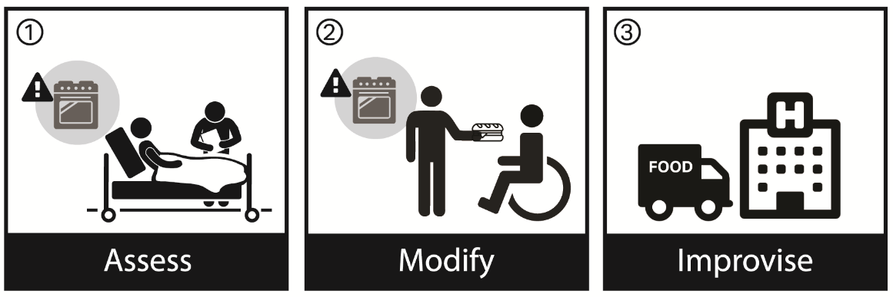

OVERVIEW
The loss of power and/or fuel sources may lead to the inability to prepare meals. Additionally, in the event the kitchen hood suppression system is out of service, no cooking on appliances located under the hood should occur.
This procedure outlines a variety of cooking options and plans.

GENERAL ACTIONS APPLICABLE TO ALL STAFF
- Emergency menus are available using food that does not require cooking (See menus attached to this procedure).
- Determine the availability of alternate areas within the facility to cook or warm food such as staff lounges, and areas with microwaves or stoves.
- Depending on the situation, the facility may contract for off-site food preparation, and mobile field kitchens, or they may use non-cooking menus.
- Dining Services will determine the needs of residents, staff, and others sheltering at the facility, and they will address supply issues.
- Advise Dining Services of food supplies on the unit, as applicable.
- Be aware of the schedule Dining Services sets up for staff dining.

ADMINISTRATOR / INCIDENT COMMANDER
- Meet with Dining Services to determine if the situation can be handled within normal operations.
- As necessary, open the Command Center to manage the incident. In coordination with Section Chiefs (Department Heads), ensure all other guidelines of this procedure are carried out. If not, all actions of the plan must be accomplished by on-duty administrative staff.

DEPARTMENT-SPECIFIC ACTIONS

DINING SERVICES
- A minimum of a 4-day supply of emergency food should be on hand at all times. (Menus must address medical and nutritional needs of residents / See Emergency Resource and Lists Section).
- Food Service priorities will be as follows:
      - Residents (if limited Food Service, review with Medical Director & Nursing)
      - Staff (Set up separate area and mealtimes for visiting families who may also be sheltering in the facility)
      - Visitors (Families)
      - Catering will be suspended
- Special Considerations:
      - Meals will be served as close to normal times as possible
      - Follow Emergency Non-Cooking Menu
- Consider using any food preparation areas that are still operational:
      - Main Kitchen
      - Coffee Shop
      - Cafeteria
      - Microwaves (throughout the facility)
- Determine if outdoor grills can be utilized for food preparation.
- Consider contracting food prep/delivery from area healthcare facilities, restaurants, schools, etc., depending on the expected duration of the incident and outside conditions.
- If cooking will be lost for an extended period of time, consider mobile field kitchens.
- If Food Service staff are not in the building and cannot return in an acceptable length of time:
      - Kitchen can be entered (fill in location and method of entry) _____________.
      - Emergency Food Supply is located (fill in location and method of entry) _______________________.
      - Follow Emergency Non-Cooking Menus attached to this procedure.
- Incident Command will work with departments to assign staff to emergency food preparation until normal staff arrives.
- The following is a list of companies to obtain prepared meals and mobile field kitchens:
      - Gardner H. Stern, Jr. Company: 1-800-738-0401
    - www.gardnerstern.com
    - Provides nationwide service
      - Stewart’s Mobile Concepts: 1-800-919-9261
    - www.stewartsmobile.com
    - Provides nationwide service
      - Kitchens To Go
    - www.kitchens-2-go.com
    - Midwest Location 1-888-212-8011
    - West Coast Location 1-888-212-0801

EMERGENCY (NON-COOKING) MENU - (STANDARD)

NOTE: Special dietary (medical and nutritional) needs of individuals must be considered as meals are being prepared. Recipes are kept: ___________________________

DAY ONE
Breakfast | Lunch | Dinner

DAY TWO
Breakfast | Lunch | Dinner

DAY THREE
Breakfast | Lunch | Dinner

EMERGENCY (NON-COOKING) MENU - (SOFT/SEMI-SOFT)

NOTE: Special dietary (medical and nutritional) needs of individuals must be considered as meals are being prepared. Recipes are kept: ___________________________

DAY ONE
Breakfast | Lunch | Dinner

DAY TWO
Breakfast | Lunch | Dinner

DAY THREE
Breakfast | Lunch | Dinner

EMERGENCY (NON-COOKING) MENU - (PUREE)

NOTE: Special dietary (medical and nutritional) needs of individuals must be considered as meals are being prepared. Recipes are kept: ___________________________

DAY ONE
Breakfast | Lunch | Dinner

DAY TWO
Breakfast | Lunch | Dinner

DAY THREE
Breakfast | Lunch | Dinner

EMERGENCY (NON-COOKING) MENU - (DIABETIC)

NOTE: Special dietary (medical and nutritional) needs of individuals must be considered as meals are being prepared. Recipes are kept: ___________________________

DAY ONE
Breakfast | Lunch | Dinner

DAY TWO
Breakfast | Lunch | Dinner

DAY THREE
Breakfast | Lunch | Dinner

RETURN TO NORMAL OPERATIONS / RECOVERY
Ability to cook restored:
- Verify with Public Health, as necessary, the fact that the kitchen is approved to restart operations.
- If only limited food serving can be offered, review with Medical Director and Nursing to determine what, if any, effects to resident care or admissions.
- Collect costs for reimbursement and develop a full report for critique.
- Have Department Heads re-stock supplies as applicable.
- Close down Incident Command.
- Critique reports and make necessary updates.

ADDITIONAL REFERENCES:
Loss of Natural Gas Procedures
Loss of Water Procedures
Loss of Sewer Service Procedures
Loss of Electric Service Procedures
Emergency Food Supply
Emergency Agency Phone Numbers
Emergency Contractor/Vendor Phone Numbers

LOSS OF ELECTRIC SERVICE

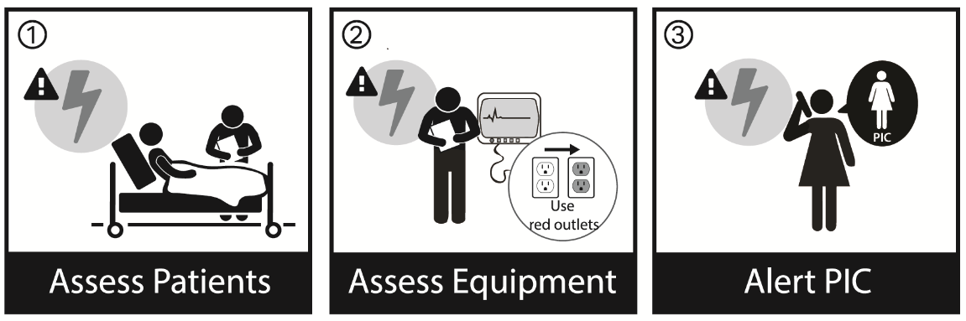

OVERVIEW
The loss of power can be critical to a healthcare facility that relies on electric powered medical equipment. Loss of power is the leading cause of healthcare facility evacuations.

GENERAL ACTIONS APPLICABLE TO ALL STAFF
- The facility is serviced by one generator which is located on the ___________ the building. The generator is a ____ KW fueled by a _____ gallon diesel tank with a ____ hours running capacity.
- In the event of an emergency, problem or failure involving any portion of the electrical system any staff should:
      - Immediately notify the Administrator, Maintenance, and the Director of Nursing.
      - Give your name, location, and the nature of the emergency. Someone from Plant Operations will be dispatched immediately to evaluate the situation and provide emergency service.
- Emergency power circuits are identified by Red Covers. See a list of services provided by the generator, in the Emergency Resources and Lists Section.
- All essential resident care equipment should be routinely connected to these receptacles. Check all such equipment to ensure it is properly plugged into these outlets and functioning.
- Backup electronic data and determine the need to shut down computers and servers.
- While the facility is operating on emergency power, all non-essential equipment should be turned off or disconnected. Also, turn off any equipment that may have been running when the power was lost.
- Open curtains and drapes to take advantage of natural or off-site lighting, as applicable.
- As necessary, request temporary lighting, flashlights, and extension cords from Maintenance.
- Follow procedures for loss of any service which has been lost in the disaster.

ADMINISTRATOR / INCIDENT COMMANDER
- Activate the Command Center by notifying the Section Chiefs and Command Center personnel by phone or pager notification and indicating a Code _____, as necessary.
- Ensure all essential departments are functioning. Determine impact on resident care, if any.
- Notify departments to complete the Department Rapid Assessment Form and forward to the Command Center.
- If all power is lost (commercial and emergency), staff would take immediate life safety actions.
- Utilize Resident TV Channel to inform residents, as necessary.
- Determine the need to report the situation to ______ or other regulatory agency. See reporting procedures in the Appendices section.

MAINTENANCE
WHEN ON GENERATOR POWER
- Check automatic transfer switch to ensure that load has transferred.
- Attempt to determine the expected duration of the electrical outage.
- Ensure Utility Company (___________________) is aware that you are a healthcare facility and request priority restoral of power.
- Ensure that the generator is functioning properly. If fuel supply is low shut down the generator before depletion.
- Check communications, IT, fire and security systems, exit alarms, electronic locks, and applicable medical equipment (i.e., suction, IV pump, ventilators) to determine what is functioning. Provide status update to Command Center.
- Ensure emergency power to utility pumps throughout the building(s), including wells, if applicable.
- The generator should be checked periodically throughout the incident (monitor/record voltage, current, fuel level and temperature).
- Restart equipment following the shutdown, as necessary.
- Advise Command and other Section Chiefs (Department Heads) of any electrical services that are not available due to the power loss.

IF AN OUTAGE IS EXPECTED TO BE FOR A LONG DURATION
- Be proactive in anticipation of replenishing fuel supplies (see Average Expected Fuel Consumption Calculations below).
  - Using a formula such as 2.5 gallons/hour per 10KW of power, project what your likely fuel consumption will be and make sure that you have supply contracts or arrangements in place. Advise Command Center on how long the fuel supply will power the generator.
  - When fuel supply drops to approximately 50%, contact vendors. You may have to make this call sooner if your supplier is out of your region.
- Confirm availability of back-up portable generators from Vendors or Office of Emergency Management.
- List of agreements with contractors who may be able to provide backup building generators are listed in Emergency Resources and Lists.
- Confirm that a fuel supply and mechanic come with the generators.
- Attain a portable, gasoline-fueled generator to run selective critical equipment (i.e., ventilators, portable A/C units, etc.). Ensure that generators operate in a safe, well-ventilated area that is outside. Use only approved safety cans for fuel. Refueling of generators will take place only after shut down and cool-off have taken place.

NURSING
- Set up portable oxygen where necessary.
- Operate life support equipment on battery back-up or manually (suction, IV pump, vent, etc.), as necessary, until emergency power takes over.
- If necessary, place an extension cord by each portable suction machine to enable one to plug the machine quickly into an outlet served by the emergency generator.
- Use extension cords to plug medication refrigerators into outlets (label the extension cord and medical refrigerator to be used only for this purpose) that are served by the emergency generator OR move necessary medications that could spoil without refrigeration (i.e., vaccines) into a refrigerator already served by the generator.
- Contact Maintenance for extension cords that will reach emergency outlets to enable beds to be raised and lowered if hand cranks are not available.
- If resident room bathroom lighting will not be served by an emergency generator; keep doors open.
- Ensure operational ability and availability of flashlights and batteries.
- Exit door alarms should operate under generator power. If the system is not powered by emergency power, request additional staffing or security for Dementia / Alzheimer’s Units, as necessary, based on loss of electronic security systems. Monitor stairwell and exit door alarms for resident safety.
- Frequently check resident rooms if the “nurse call system” is not working.
- CRITICAL CARE RESIDENT AREAS:
  - For critical medication pumps and ventilator-dependent residents, set up portable oxygen tanks and supervise manual ventilation and medication dosage, if necessary.
  - Evaluate the need to transfer high acuity residents to acute care based on the projected duration of outage and residents’ conditions.

DINING SERVICES
- Remove food from refrigerators and freezers not powered by the emergency generator and transfer food to refrigerators/freezers served by the generator. This would also apply to ice machines.
- For freezers not on emergency generators, keep doors closed as much as possible. If spoilage is possible, start cooking applicable items.

PHARMACY
- Reset electronic medication carts and scanners on each unit, as necessary.

LOSS OF ELECTRIC SERVICE DURING DIALYSIS

DIALYSIS STAFF
- If power fails while a resident is on dialysis, the following will occur:
  - The air foam detector alarms then clamp the venous line.
  - The blood pump stops.
  - The machine sounds a power failure alarm.
  - The generator should activate within __ seconds.
  - The person in charge should notify Maintenance. Try to ascertain when the power might be restored.
  - Ensure machine plugs are properly planned in emergency outlets.
- If the generator does not activate, Nursing responsibilities are to:
  - Using hand crank during power failure:
- Turn the power switch off.
- Clamp arterial and venous blood lines.
- Raise blood level in venous drip chamber.
- Remove venous blood line from air detector.
- Locate hand crank and insert crank into blood pump (if applicable).
- Open normal saline and observe venous drip chamber. If no air is present, unclamp the blood lines. Crank by hand in direction of blood flow.
- If a resident is able and instructed, he/she may perform the procedure.
- If power will be restored in 10 -15 minutes:
  - Discontinue dialysis in the usual manner using the hand crank the of the blood pump.
  - Maintain minimum negative pressure.
  - Hand crank slowly to prevent a rise in venous pressure.
  - Watch venous pressure monitor and watch for air in the lines.
  - Use heparinized saline to flush fistula needles and irrigate every 10 minutes until treatment is to be restarted.
- If power will not be restored in 10 -15 minutes:
  - Terminate dialysis.
  - Return blood manually, following routine rinse-back procedure.
- If dialysis treatment for residents cannot be safely rescheduled, transfer the resident to a hospital.

LOSS OF EMERGENCY GENERATOR POWER

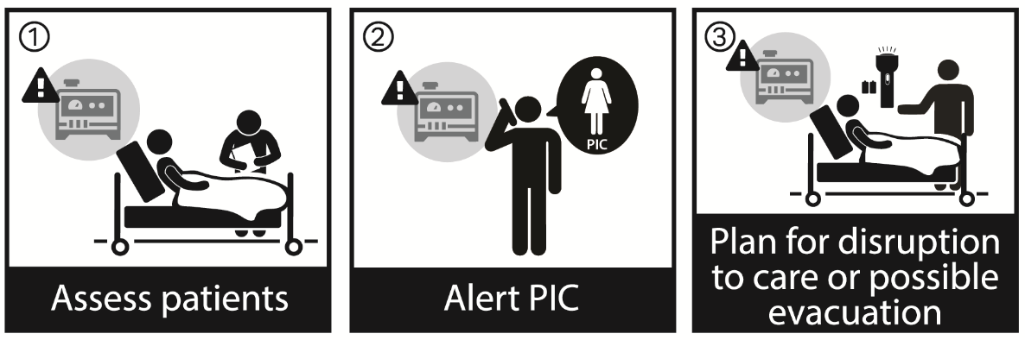

GENERAL ACTIONS APPLICABLE TO ALL STAFF
- Where uninterrupted power supply and battery backup are present, immediately save important data by powering down computer equipment and other applicable items before batteries run out.
- Complete the Department Rapid Assessment Form and inform the Command Center of your ability to function.

ADMINISTRATOR / INCIDENT COMMANDER
- Activate the Command Center by notifying the Section Chiefs and Command Center personnel by phone or pager notification and indicating a Code ______.
- Resident care staff will begin life safety procedures for residents. Immediately assess needs in resident care areas.
- Establish which position will notify the Fire Department and/or Police Department if staff should call out a disaster code word or if there is a fire. Use a cell phone or runner to contact the Fire Department to advise them that your fire alarm and communications are down.
- In the event of a generator failure, and the loss of commercial power, the following would be required. If these items cannot be provided within an acceptable length of time, evacuation of the building would have to be considered. See Section D: Full Building Evacuation Plan.
      - Essential Services Requiring Electrical Power:
- Egress illumination (corridors, stairways, and landings)
- Exit and directional signs
- Communications (telephone, nurse call, etc.) and fire alarm system
- Resident care areas (lighting and power for life support systems such as suction, vents, etc.)
- Task lighting and power in service areas and clinical areas
- Oxygen
- Elevators
- Air handling units
- Critical water pumps
- Determine need to report situation to _________or other regulatory agency.

NURSING
- Immediately address life support in high acuity areas (i.e., dialysis, ventilators):
  - Provide portable oxygen tanks, as necessary.
  - Monitor battery backup for IV pumps. Be ready for manual operations if batteries should fail.
  - For residents on ventilators, provide manual ventilation and oxygen tanks, as necessary. Respiratory Therapy should assist.
- Request security for Dementia / Alzheimer’s areas is doors unlocked or monitoring is affected by the loss of power.
- Evaluate the need to transfer high acuity residents to acute care based on the projected duration of outage and residents’ conditions.
- Place heat-sensitive medications in a cooler with ice.

MAINTENANCE
- Secure portable generator(s).
- List of agreements with contractors who may be able to provide backup building generators are listed in Emergency Resources and Lists.
- Portable generator can be positioned in the parking area adjacent to the existing generator and connected using a ___ length of cable.
- When connecting a backup generator to the building, open the main disconnect switches in the Switchgear Room to prevent back feed when commercial power is restored.
- If the fire detection system is out of service (4 hours in a 24-hr. period), the facility should notify the Fire Department and establish a fire watch. See Loss of Fire Protection Systems procedure.

RETURN TO NORMAL OPERATIONS / RECOVERY
Upon restoration of normal electric power:
- Determine the status of the facility.
- Cost for reimbursement and develop a full report for critique.
- Have Department Heads re-stock supplies as applicable.
- Close down Incident Command.
- Critique reports and make necessary updates.
Maintenance:
- Verify stability of commercial power with the utility company.
- Check generator for proper fluid levels and ensure that all circuits have transferred properly.
- Notify each department, as necessary, of procedure for turning equipment back on to avoid all equipment being turned on at once, resulting in a massive power draw.
- Check life support equipment.
- Check all communications systems.
- Check all refrigerators and freezers for proper operation.
- Check HVAC units and boilers for proper operation.
- Reset all clocks, lighting, and other timers.
- Check all pumps.
- Check fire alarm system to ensure proper operation.
- Check all elevators for proper operation on normal power.
- Check manual transfer switches.
- Check all motor control centers.
- Ensure generator is properly serviced and maintained if run for a long period of time.

IT Department:
- Check all computer systems. Retrieve information, as necessary.

Nursing:
- Re-check medical equipment to ensure proper operation.
- Evaluate residents.

Dining Services:
- Dispose of any perishable items that may have been exposed to unsafe storage temperatures.

ADDITIONAL REFERENCES:
Loss of Air Conditioning System / High Heat Procedure
Loss of Cooking Ability Procedure
Loss of Heating System Procedure
Loss of Telephone / Internal Communications Procedure
Loss of Water Service Procedure
Loss of Fire Protection System Procedure
Emergency Resources and Lists:
Emergency Utility Shut-Off Locations
List of Equipment Served by the Emergency Generator

LOSS OF ELEVATOR SERVICE

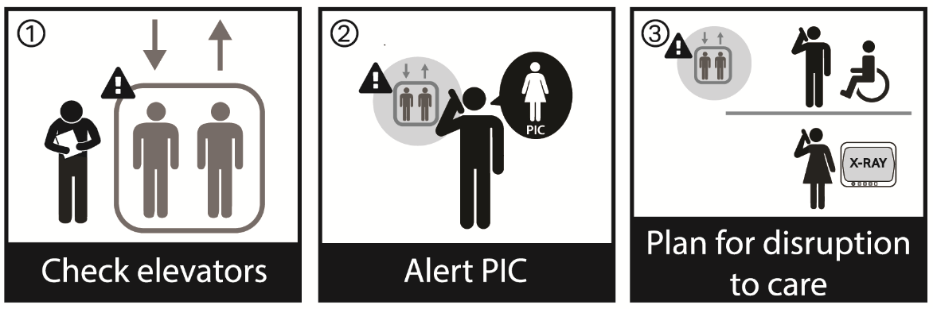

OVERVIEW
Elevator access to floor above and below grade is essential to the movement of people and supplies. In high-rise buildings in particular, the loss of elevator service can significantly affect the ability to provide services and maintain operations.

GENERAL ACTIONS APPLICABLE TO ALL STAFF
- Notify Administration and Maintenance.
- Determine if anyone is on the elevator. Assure individuals inside the elevator that they will be rescued.
- Determine if there are injuries. If any occupants are injured, notify the Fire Department and Ambulance Service.
- While communicating with passengers, obtain the following information:
  - Number of passengers on elevator.
  - If there are residents in the elevator, their names, room numbers, and apparent condition.
  - If there are staff members in the elevator, their status, and units or department numbers.
  - Any immediate problems in the elevator.

ADMINISTRATOR / INCIDENT COMMANDER
- Determine extent of outage with Maintenance and the impact it will have on facility operations and resident care. Activate Incident Command, if necessary.
- If the elevator is not operable for an extended period of time, notify staff and develop an action plan. Determine if resident movement, food, or supply deliveries will be impacted.
- Post an individual at Reception/Lobby area to explain the situation to incoming persons, or post signs at the elevator indicating that it is out of service. Provide directions to alternate elevator[s] and/or stairwells.
- If elevators will be out of service for an extended time, handicapped staff will be assisted to the Ground Floor by appropriate persons.

NURSING
- Plan to take necessary services and supplies to residents.
- If all elevators are out of service, arrange for emergency-related vertical transport of residents, as necessary, via Fire Department, EMS, and facility staff.
- Consider:
  - Relocation of selected residents to lower floors
  - Any temporary suspension of services or admissions
- Provide medical assistance, as necessary, to injured occupants.
- Determine if any non-ambulatory residents are scheduled to leave the facility during the outage for doctor appointments, testing, etc.

MAINTENANCE
- Notify elevator service contractor. Request estimated time of arrival of service personnel.
- Do not attempt to force open doors or remove occupants without advice from the elevator service contractor.

DINING SERVICES
- If the elevator will be out of service during mealtimes, staff should be organized into a “transport line” for moving meals to upper floors.

RETURN TO NORMAL OPERATIONS / RECOVERY
Upon restoration of elevator service:
- Have Maintenance verify with contractor that the elevators are fully functional.
- Develop a full report for critique.
- Close down Incident Command.
- Critique reports and make necessary updates.

LOSS OF FIRE PROTECTION SYSTEMS

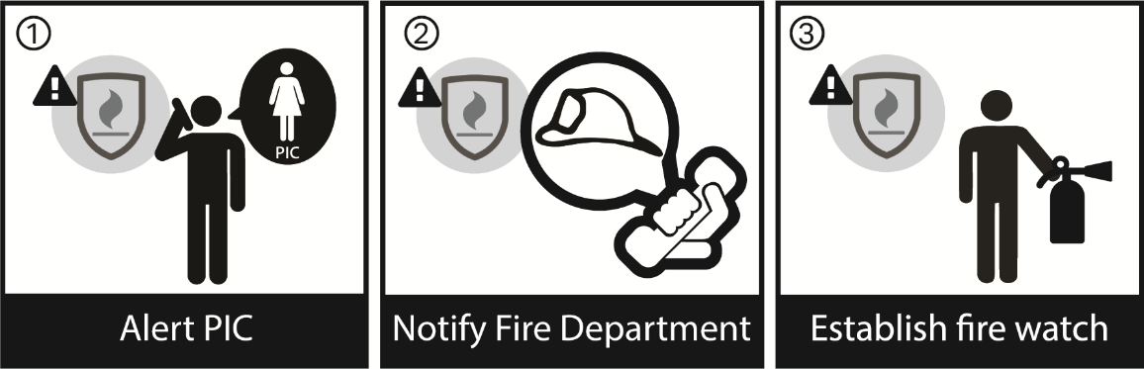

OVERVIEW
A fire detection and alarm system is installed in the facility. The system includes manual pull stations, smoke detectors, audible/visual alerting devices, automatic sprinkler water flow indicators, and valve position monitors to indicate tampering. Additionally, the fire alarm system causes the notification to the Fire Department.

The facility also has automatic suppression systems as follows:
- Automatic Sprinkler System throughout the building
- Kitchen cooking area hood suppression system

If staff observe the failure of any of these systems, or observe any problems related to the Fire Protection Systems, this should be immediately reported to both Maintenance and the Administrator.

Note: In the event the kitchen hood suppression system is out of service, no cooking on appliances located under the hood should occur. A fire involving those appliances could spread through associated ductwork.

ADMINISTRATOR / INCIDENT COMMANDER
- Activate the Command Center by notifying Section Chiefs and the Command Center.
- In the event of a system failure of the fire alarm system, smoke detection system, power systems, or sprinkler system, the following actions shall be taken immediately by the facility:
  - Notify the local fire department (<insert FD name and telephone #>) and document instructions.
  - Notify all staff working in the building of the impairment
- Assess the extent of the condition and effect corrective action, within a documented period. If the corrective action to repair the Fire Alarm Detection System will take more than four (4) hours, or the Fire Suppressions System will take more than 10 hours, the following items shall be completed:
  - Implement a contingency plan to the facility fire plan containing: a description of the problem, a specific description of the system failure, and the projected correction period.
  - Establish a fire watch for Fire Alarm Detection impairments of more than 4 hours in duration, or Fire Suppression impairments of more than 10 hours in duration (see Fire Watch Procedure).
  - For extended impairments, notify the facility insurance company.
- All staff on shifts involved shall have documented in-service training for the emergency contingency. Provide education to staff on steps to take during the impairment, as appropriate:
  - Fire alarm impairment – review the use of the facility code word, “Code Red,” method for announcing fire situations and locations via the fire alarm system (if operational) or via portable phones/radios carried by staff, and the necessity for contacting 911 directly to notify the fire department of a fire emergency.
  - Sprinkler system impairment – review the location and use (P.A.S.S.) of fire extinguishers with staff.
- Ensure notifications have been made to the local fire department.
- Ensure the appropriate service vendor has been notified.
- Notify State Health Department or other regulatory agency, as necessary.

DEPARTMENT-SPECIFIC ACTIONS

MAINTENANCE
- Review all system outages and provide the Incident Commander or Person in Charge with an assessment of the situation.
- Service contractors shall be notified as soon as possible. Provide the Incident Commander or person in charge with an estimated time period before the system(s) are restored.
Fire Watch Procedures

A fire watch will be implemented in the event the fire alarm system and/or the sprinkler system is out of service (OOS) for an extended period of time including:

  - Fire Alarm System – OOS for 4 or more hours (NFPA 101, 2012 Edition)
  - Fire Sprinkler System – OOS for 10 or more hours (NFPA 25, 2011 Edition)

It may also be implemented if requested by the Authority Having Jurisdiction.

In the event a fire watch becomes necessary, the following procedures will be implemented:

  - The fire watch will be conducted by an individual specifically assigned for the purpose of the fire watch. The individual shall not have other facility responsibilities. Individuals assigned to perform a fire watch shall be looking for the signs of fire and/or smoke. In addition, they shall monitor the facility in an attempt to mitigate the potential for a fire to occur by looking for:
- Electric overloads
- Overheated electrical equipment
- Burners left on where stove tops are present
- Dryer lint buildup in the laundry area
- Smoking violations
- Any other possible fire hazards

- If a fire is discovered when the fire alarm system is out of service, staff in the fire area will be responsible to make a page and/or radio announcement of the fire’s location in place of activating the fire alarm.

NOTE: See attached checklist for fire watch.

- The local fire department shall be notified that a fire watch has been established along with <Insert regulatory agency name>.

- The facility will also notify the following when a fire watch has been initiated:
- Applicable facility leadership (i.e., Maintenance, Administrator, etc).
- Insurance carrier (if required by the carrier)
- Notify State Health Department or other regulatory agency, as necessary.

FIRE WATCH FREQUENCY
A fire watch tour of the entire building shall occur and be logged every hour unless otherwise required by the Authority Having Jurisdiction.

CANCELLATION OF THE FIRE WATCH
The fire watch may conclude when the projected correction period changes or when the system is restored to normal operation. The facility shall notify the __________ and local fire authorities.

FIRE WATCH CHECKLIST

Building: _______________________ Date/Time Fire Watch started: ______________________

Date/Time Fire Watch completed: ______________________

Reason for Fire Watch (explain):____________________________________________________

ITEM | LIST LOCATIONS | CHECKED
EXITS UNOBSTRUCTED | Throughout
FIRE EXTINGUISHERS UNOBSTRUCTED | Throughout
SMOKE BARRIER DOORS UNOBSTRUCTED | Throughout
FIRE ALARM PULL STATIONS UNOBSTRUCTED | Throughout
CORRIDOR DOORS ARE NOT PROPPED OPEN | Throughout
HAZARDOUS ROOM DOORS ARE NOT PROPPED OPEN | Soiled Utility Rooms  Fuel Fired Equipment Rooms  Storage Rooms >50 sq. ft.
OXYGEN STORAGE IN PERMITTED LOCATIONS | Insert locations
NO ELECTRICAL OVERLOADS | Throughout
NO DRYER LINT BUILDUP | Laundry
KITCHEN SUPPRESSION SYSTEM FUNCTIONAL | Kitchen
EXTENSION CORDS ONLY USED AS PERMITTED | Throughout
SMOKING ONLY OCCURS IN PERMITTED SMOKING AREAS | Amend as necessary
Insert Notes Regarding Situations Found and How They Were Mitigated:

Name/Title of person conducting Fire Watch (Print): ____________________________

Signature of person conducting fire watch: ____________________________________

LOSS OF HEATING SYSTEM

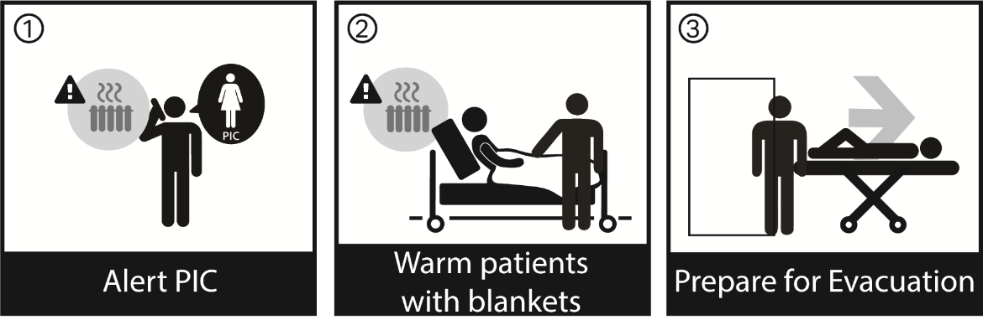

OVERVIEW
The inability to heat the facility can be a critical issue in many parts of the country. The loss of heating systems should be assessed quickly to determine if the situation can be remediated while temperatures remain steady in the building. If not, partial or full building evacuation may be necessary.

GENERAL ACTIONS APPLICABLE TO ALL STAFF
Note: Loss of water and/or electric may result in the loss of heat in some buildings on the campus.
- Expected duration of the outage, along with outside weather conditions, must be evaluated before possible building evacuation is considered. (If necessary, see Full Building Evacuation Plan.)
- All staff should survey their assigned areas to ensure that all windows and doors are closed. Any windows or doors that do not seal effectively should be reported to Maintenance.
- Heating in resident homes may be independent of systems that provide heat to common areas of the building.

ADMINISTRATOR / INCIDENT COMMANDER
- Activate the Command Center by notifying the Section Chiefs and Command Center personnel.
- Determine extent of outage with Maintenance and impact it will have on facility operations and resident care.
- Determine if portions of the building can be used to safely house residents within the State temperature requirements. Continuously monitor building temperatures.
- Adjust employee dress code, as needed.
- Evaluate conditions for possible census reduction or evacuation of residents compromised by loss of heat. See Resident Census Reduction and Full Building Evacuation Plan.

MAINTENANCE
- Attempt to determine expected duration of heating system outage.
- Shut down fresh air systems, as applicable, based on outside air temperature. Depending on outside conditions, if temperature is below 50º Fahrenheit, the ventilation fans will be shut down, and the fresh air systems will be shut down.
- Advise Infection Control.
- Monitor building temperatures.
- Institute actions necessary for the repair of the heating system.
- Determine if alternate heat source can be utilized to warm selected areas.
- Determine ability to switch to alternate methods of heat or consider contacting a vendor to provide a portable heat source (boiler), if practical.

FREEZING OR LOW TEMPERATURES:
      - If Evacuating the Building:
- Ensure water-cooled equipment, which has not been otherwise protected, is drained.
- Ensure condensed moisture from compressed air lines is drained frequently.
- If heat loss will last for an extended period of time, drain compressors, condensate piping, hydraulically operate devices and air conditioning systems.
- Institute emergency procedures for processes that depend on steam or water supply.
- Drain piping systems that contain liquids, other than water, which are vulnerable to freeze-ups.
- Check pressure-vessel vents, as well as relief and safety valves for obstructions such as frozen condensate.
- Ensure sprinkler systems are checked regularly to make sure they are operational.
- Check the water temperature of the fire pump suction tank.
- Maintain a temperature above 40ºF (4ºC) in rooms with wet/dry pipe sprinkler system valves and electric-powered fire pumps. Rooms housing diesel engine driven fire pumps should be maintained at 70ºF (21ºC).
- Ensure air handlers remain on and temperatures are monitored in any areas where medications are stored.

NURSING
      - Dress residents with several layers of loose clothing, two pairs of socks, bathrobes, slippers, etc.
      - Use extra blankets, including bath blankets.
      - Group residents into rooms, if possible.
      - Establish activities to keep residents active, as practical.

OT/PT/ACTIVITIES
- Adjust therapy and activities, as appropriate.

HOUSEKEEPING/LAUNDRY
      - Provide blankets to Nursing Department.
      - Consider using additional resident clothing that may be stored in the facility.

DINING SERVICES
- Provide hot foods and drinks, as applicable.

RETURN TO NORMAL OPERATIONS / RECOVERY
Upon restoration of the heating system:
- Have Maintenance verify heating system operations and other utilities that may have been damaged due to heat loss.
- Collect cost for reimbursement and develop a full report for critique.
- Have Department Heads re-stock supplies as applicable.
- Close down Incident Command.
- Critique reports and make necessary updates.

ADDITIONAL REFERENCES:
Emergency Utility Shut-Off Locations
Emergency Contractor/Vendor List
Full Building Evacuation Plan
Resident Census Reduction Plan

LOSS OF INFORMATION TECHNOLOGY

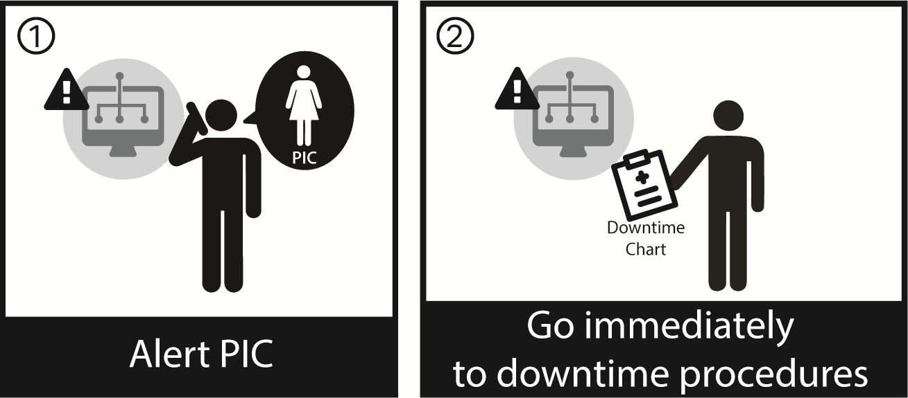

OVERVIEW
The loss of IT affects everything in the facility from medical records to ordering pharmaceuticals. As such, it is considered a critical infrastructure component.

GENERAL ACTIONS APPLICABLE TO ALL STAFF
- If advanced warning is possible, save and back up all work, then shut down your computer. Most UPS devices have a 30 – 60 minute battery backup.
- With systems down, the facility will have to go to “Down Time” procedures for necessary records.
- Each department maintains its own “Down Time” procedures.

ADMINISTRATOR / INCIDENT COMMANDER
- As necessary, consider activating the Command Center by notifying the Section Chiefs and Command Center personnel.
- Together with IT staff, assess the impact on facility operations and resident care and develop an action plan. Determine the ability to access offsite backup data and/or Cloud storage for backup data.
- Notify all departments to activate down-time procedures.
- Determine need to report situation to your regulatory agency.

INFORMATION SYSTEMS
- Inform departments of disruption and duration via call lists or other contact information.
- Ensure departments are using paper back-up procedures, as appropriate.
- Request all departments to complete a Departmental Rapid Assessment Form and forward to the Command Center by fax or runner.
- Prioritize system recovery, if needed, with focus on first priority systems:
- Patient Care Services such as Electronic Health Records, Medication/Pharmacy Med Cart Interface
- Security Systems and related Apps
- Maintenance Building Automation Systems
- Facility Intranet – (HR and Payroll)
- Followed by other mission critical systems:
- Material Management System
- A/P General System
- Attempt to determine cause of problem and expected duration of systems down. Provide this information to the Command Center.
- Initiate repair process.

MAINTENANCE
- Utilize paper back-up procedures for building mechanical systems controlled by computer, or the electronic work order system.
- Go to manual ordering.

DINING SERVICES
- Utilize paper back-up procedures.
- Use resident tray “hardcopy” list from unit to prepare meals.
- Utilize paper backup procedure forms to record dietary needs of new admissions manually.
- Go to manual ordering.

CENTRAL SUPPLY
- Utilize paper back-up procedures to record and maintain inventory use.
- Go to manual ordering.

NURSING / SUPERVISOR
- Electronic Health Records including Pharmacy and EMARs:
- Utilize paper backup for records.
- Distribute reports, as necessary.
- Maintain manually.
- Hand-write labels.
- Go to manual ordering.
- Once system is back up, re-enter new data.
- Manually open medication dispensing machine.

PHARMACY
- Utilize paper back-up for records.
- Distribute reports, as necessary.
- Maintain manually.
- Hand-write labels.
- Go to manual ordering.
- Once system is back up, re-enter new data.
- Reset electronic medication carts, as needed.

RETURN TO NORMAL OPERATIONS / RECOVERY
Upon restoration of the IT system:
- Have IT/IS staff verify electronic systems are up and running.
- Assess department operations, based on downtime.
- Have IT work with departments which may be having trouble coming back up or retrieving lost information.
- Determine if any financial impact on the facility and develop a full report for critique.
- Close down Incident Command.
- Critique reports and make necessary updates.

LOSS OF NATURAL GAS/PROPANE

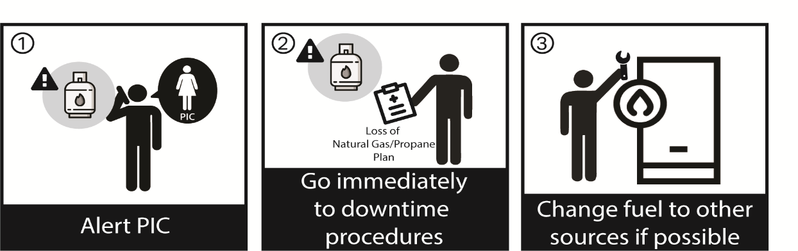

OVERVIEW
Fuels such as natural gas and propane can have a direct impact on heating, cooking and other critical functions.

GENERAL ACTIONS APPLICABLE TO ALL STAFF
- Services dependent upon equipment fueled by natural gas/propane may be disrupted should there be a loss of gas service to the facility.
- The following equipment is fueled by natural gas/propane:

ADMINISTRATOR / INCIDENT COMMANDER
- Activate the Command Center by notifying Section Chiefs and Command Center personnel.
- Evaluate conditions for possible evacuation if safe resident care cannot be continued.
- Request all departments to complete a Departmental Rapid Assessment Form and forward to the Command Center by fax or runner.
- Determine need to report situation to _________ or other regulatory agency.

DINING SERVICES
- The following services will be affected:
- ________________________________________
- ________________________________________
- See Loss of Cooking Ability procedures.
- Determine if alternate methods of cooking can be used such as microwaves, outdoor gas grills, butane burners, etc.

MAINTENANCE
- Domestic boilers/hot water, dryers and kitchen appliances will be affected.
- Attempt to determine expected duration of gas supply outage.
- Shut off valves supplying any appliances that have pilot lights (kitchens / boilers).

LAUNDRY
- Dryers operate on gas, shut off gas until restored.
- Provide Linen inventory to the Command Center.
- Coordinate reduction of linen changes with Nursing.

NURSING
- The following services will be affected:
- Hand washing and other resident care services that may depend upon hot water (bathing, showering)
- Laundry – linen services may be reduced.
- Restrict resident bathing. Use wet wipes for hygiene needs.
- Use waterless hand cleanser or cold water where possible.
- Use disposable pads to reduce the need for linen changes.
- Use pre-mixed, pre-packaged enemas.

RETURN TO NORMAL OPERATIONS / RECOVERY
Upon restoration of the natural gas/propane:
- Have Maintenance verify integrity of natural gas/propane service.
- Upon restoration of gas supply, have Maintenance re-light all pilot lights and check all gas appliances for proper operation.
- Collect cost for reimbursement and develop a full report for critique.
- Have Department Heads re-stock supplies as applicable.
- Close down Incident Command.
- Critique reports and make necessary updates.

ADDITIONAL REFERENCES:
Loss of Heating System Procedures
Emergency Contractor/Vendor Phone Numbers
Emergency Utility Shut-Off Locations
LOSS OF OXYGEN / VACUUM

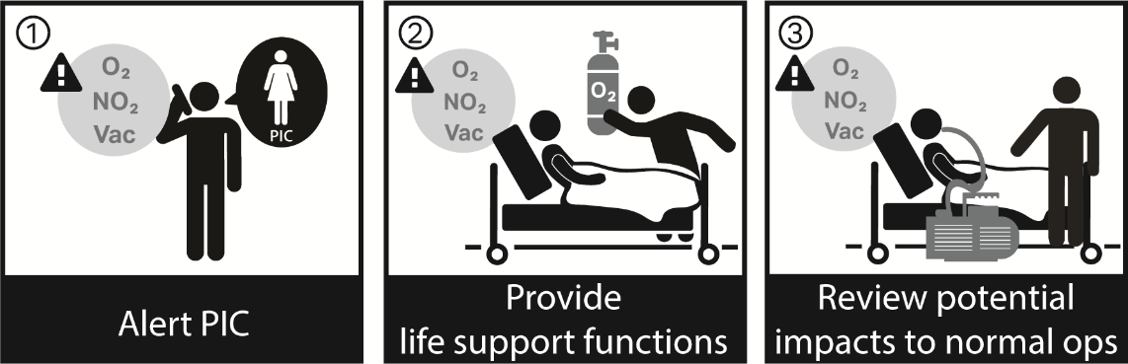

OVERVIEW
The loss of medical gas systems has a direct impact on patient care.

GENERAL ACTIONS APPLICABLE TO ALL STAFF
- Responsibilities of personnel discovering the malfunction:
  - Immediately inform Respiratory Therapy, Nursing & Maintenance that there is a problem with the medical gas or air central supply.
- The facility maintains a supply of oxygen tanks for use, should an emergency arise. This supply should satisfy the facility’s needs until the situation can be corrected or additional temporary measures can be implemented.
- Staff must immediately assist with life support functions, as directed, and ensure that Respiratory Therapy is informed.

ADMINISTRATOR / INCIDENT COMMANDER
- Consider activating the Command Center and assigning positions to manage the incident and ensure all other guidelines of this procedure are carried out. If not, all actions of the plan must be accomplished by on-duty administrative staff.
- Consult with Respiratory Therapy and Maintenance regarding the ability to meet the residents’ needs with the supply on hand and determine the need to place orders for additional oxygen supplies.
- Inform applicable areas of the problem and the need to use portable units.

RESPIRATORY THERAPY
- Determine the requirements for Oxygen. Notify Command Center of the need for additional portable units. Contact Oxygen vendor to determine estimated time of delivery.
- Distribute portable units to areas of need. Prioritize by Acuity (i.e., ventilators).
- Track where tanks are distributed.
- An emergency supply of portable oxygen tanks is stored _________________.

MAINTENANCE
- Notify all resident care areas to use portable oxygen tanks until further notice.
- Determine the extent of the problem and arrange for repairs. Advise Command Center of status.
- The Oxygen delivery system emergency shutdown is located ______________.
- If malfunction / failure of Oxygen delivery system: notify the supplier to send repair personnel and additional supply tanker for connect to “Emergency Low Pressure Gaseous Oxygen Inlet,” located ___________________________.
NOTE: There are portable units if primary system fails.

NURSING
- Determine need for portable suction machines. Notify Command Center.
- Portable suction machines are stored ________________________.
- Evaluate need to transfer high acuity residents to acute care based on projected duration of outage and residents’ conditions.

RETURN TO NORMAL OPERATIONS / RECOVERY
Upon restoration of oxygen:
- Assess department operations, based on situation.
- Determine status of facility oxygen supply.
- Develop a full report for critique.
- Have Department Heads re-stock supplies as applicable.
- Close down Incident Command.
- Critique reports and make necessary updates.

ADDITIONAL REFERENCES:
Emergency Contractor/Vendor Phone Numbers
LOSS OF SEWER / WASTE SYSTEM

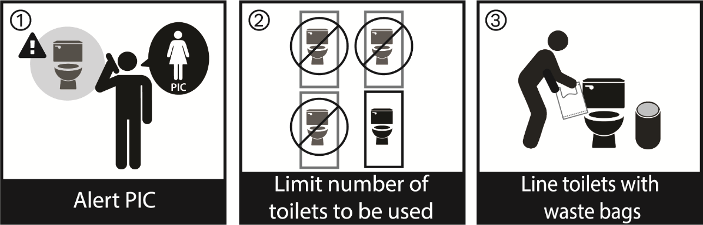

OVERVIEW
Sewage and waste systems are critical to maintain a safe environment within and around the facility.

GENERAL ACTIONS APPLICABLE TO ALL STAFF
- If you discover the situation, notify your Department Head, Maintenance and Administration.
- Selected toilets and areas will be used.
- If the sewer system is damaged, bed pans, commode chairs, or toilet bowls can be lined with waste bags and waste material collected if toilets cannot be force flushed.
  - A small amount of chlorine bleach or kitty litter should be poured into each bag prior to sealing. Large receptacles (linen barrels, garbage pails, etc.) with tight fitting lids may also be lined with waste bags for storing waste material collected in smaller bags.
- If sewer system is intact, and appropriate pumps are operable, toilets can be force-flushed by pouring a pail of water into the bowl.
- Use waterless hand sanitizer often.

ADMINISTRATOR / INCIDENT COMMANDER
- As necessary, activate the Command Center by notifying Section Chiefs and Command Center personnel.
- Assess impact on campus operations and resident care. Develop an action plan.
- Notify Infection Control and all critical areas of outage.
- Together with Command Center staff, determine operation and serviceability of facility. Keep all updated.
- Determine need to report situation to ________ or other regulatory agency.

MAINTENANCE
- Shut off applicable water valves.
- Contact plumber/sewer department and attempt to determine expected duration of incident. Arrange for repairs, if applicable.

HOUSEKEEPING
- Establish an area to store containers of waste matter. Consider storage on the exterior of the building.
- Determine availability of portable toilets from outside vendors.
- If force flushing toilets, coordinate with Nursing and other departments regarding which toilets on each unit/floor will be used. Provide pails of water at site to be used to force flush the toilets. Water will be obtained from ________________.
- Post signs and place bags over toilets and urinals which are not to be used, informing staff and others which toilets are for their use.
- If using waste bags, keep a supply at all toilets that are to be used.
- Ensure liquid consumption is given primary consideration when assessing available potable water.
- Work closely with the person responsible for Infection Control to minimize contamination.
- Provide hand sanitizers at toilet sites.

ALL OTHER DEPARTMENTS
- Coordinate with Maintenance to determine which toilets will be available for use (force flushing or waste bags).
- If force flushing, notify Maintenance / Housekeeping when more water is needed.
- Complete Department Rapid Assessment Form for Incident Command, if requested.
- Use waterless hand sanitizers often.

RETURN TO NORMAL OPERATIONS / RECOVERY
Upon restoration of sewer and toilet system:
- Have Maintenance verify repairs.
- Have Infection Control / Maintenance ensure all waste materials are cleaned up.
- Get clearance from Public Health Authorities, if necessary.
- Assess staff and department operations, based on situation.
- Have Department Heads re-stock supplies as applicable.
- Develop a full report for critique.
- Close down Incident Command.
- Critique reports and make necessary updates.

ADDITIONAL REFERENCES:
Loss of Water Service Procedures
Emergency Contractor/Vendor List

LOSS OF STEAM PRESSURE

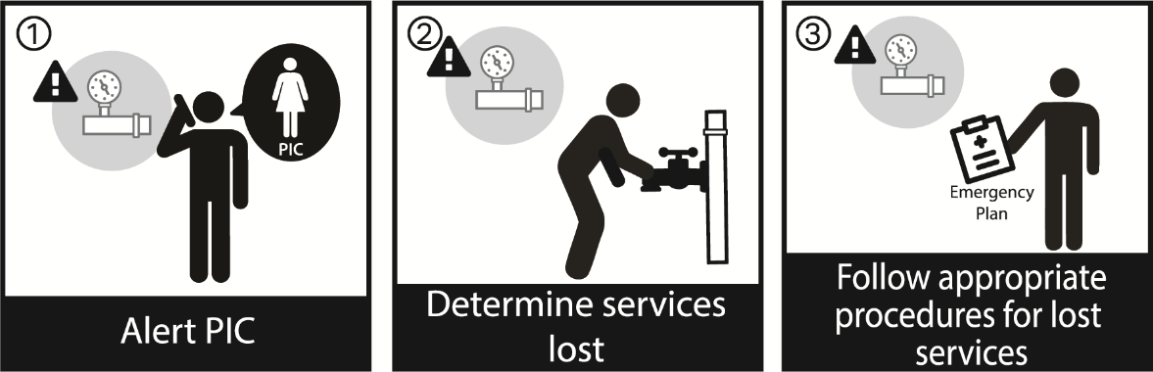

OVERVIEW
The facility utilizes steam to heat the building.

GENERAL ACTIONS APPLICABLE TO ALL STAFF
- The services lost as a result of the loss of steam pressure include:
  - _________________
  - _________________
  - _________________
- Take appropriate actions.

ADMINISTRATOR / INCIDENT COMMANDER
- Consider activating the Command Center and assigning positions to manage the incident and ensure all other guidelines of this procedure are carried out. If not, all actions of the plan must be accomplished by on-duty administrative staff.
- Assess impact on facility operations and resident care. Develop an action plan.

MAINTENANCE
- Investigate cause of loss of pressure and determine expected duration of outage, if possible.
- Notify Administrator / Command Center of services lost.
- If boiler is affected, engage back-up boiler or switch to an alternate heating source. If loss is due to a power loss, and the generators are operable, restart the lead boiler on gas.
- Arrange for repairs to system.

HOUSEKEEPING / LAUNDRY
- Notify Command Center regarding inventory of clean linen.
- Develop plan for linen reduction with Nursing.
- Arrange for alternate laundry service.
NURSING
- Suspend resident showering. Use bed baths or waterless bathing products.
- If the ability to sterilize equipment or instruments is lost, use disposable instruments or cold sterilization as applicable.

DINING SERVICES
- Alter menus that require steam.
- Use non-cooking menu, as necessary.

RETURN TO NORMAL OPERATIONS / RECOVERY
Upon restoration of steam pressure:
- Have Maintenance verify operation of steam pressure operations.
- Assess department operations for return to normal operations, as necessary. Request Department Rapid Assessment Forms be completed.
- Develop a full report for critique.
- Have Department Heads re-stock supplies as applicable.
- Close down Incident Command.
- Critique reports and make necessary updates.

ADDITIONAL REFERENCES:
Loss of Heat Procedures
Loss of Cooking Procedures

LOSS OF TELEPHONE SERVICE, INTERNAL COMMUNICATION SYSTEM, AND/OR NURSE CALL SYSTEM

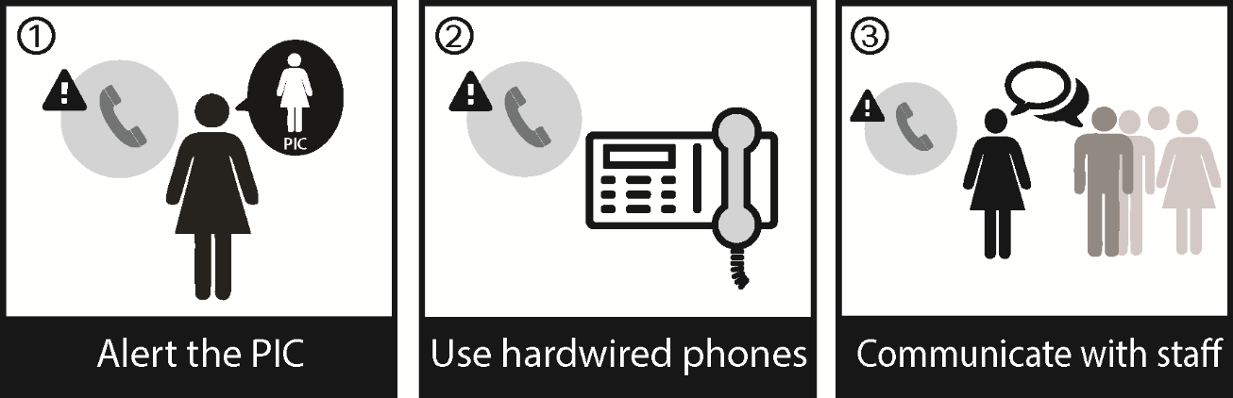

OVERVIEW
Internal communications systems such as phone and nurse call systems are critical for ensuring emergency communication.

GENERAL ACTIONS APPLICABLE TO ALL STAFF
- If internal or external communications are found to be inoperable, notify your supervisor as soon as possible.
- The facility telephone system has the following safeguards:
  - ______________________________________
  - ______________________________________
- See alternate communication methods below if normal communication systems fail.
- See list of phones not part of the main phone system attached to this procedure, which may continue to be operational.

ADMINISTRATOR / INCIDENT COMMANDER
- Activate the Command Center by notifying the Section Chiefs and Command Center personnel.
- Assess impact on facility operations and resident care. Develop an action plan.
- Consider:
  - Determine if telephones, not part of the main telephone system, are in service (list attached to this procedure). Check different lines, such as the fax, modem, etc. If a line is found to be operable, assign someone to it.
  - Determine availability and effectiveness of cellular telephones from staff and visitors.
  - Assign runners to use off-site telephones, as applicable.
  - Establish methods to communicate within the building (runners, portable radios, etc.) if intercom/paging system is affected.
  - Notify telephone company and request a supply of cellular phones.
  - Notify Fire and Police Departments. Ensure that all staff are familiar with the method to notify Fire and Police Departments in the event of an emergency while experiencing a loss of telephone service. Methods of communication could include cell phones, portable radios, etc. Amateur radios and operators may be available through your local Office of Emergency Management.
  - If all phone systems are down, overhead paging / announcements will be done as follows:
    - Overhead Paging System
    - Blast emails
    - Cell phones
    - Runners, as necessary
- Based on the down-time estimate, Maintenance will determine if any of the following steps must be taken:
- Set up off-site communications “tied” by radio, cell phone, or runner to Command Center.
- Public Information Officer will notify the news media (primarily TV and radio) that a problem has occurred and the estimated down time. Request they notify the public that only emergency calls should be attempted to the facility.
- Request that the phone service provider offers a temporary communication process if available and necessary.
- Determine if additional personnel should be called in.
- Ensure all other guidelines of this procedure are carried out.

INTERNAL COMMUNICATIONS - CONSIDER THE FOLLOWING:
- Assign portable radios to appropriate individuals/areas of the building.
- Blast emails can be sent to Department Managers and others, as necessary.
- Assign runners to assist with communication throughout the building.

NURSING
- If Nursing Call System is inoperable, provide Tap or Hand Bells to residents and increase monitoring of residents. Tap or Hand Bells are stored _______________.
- Consider moving residents closer to the Nursing Station that need closer supervision or monitoring.

MAINTENANCE
- Advise all departments of the special fail-safe telephone systems in your building.
- Facility’s telecommunications person (or vendor) should analyze problem and initiate repairs.
- Once outside communication is established, attempt to determine the extent and expected duration of the outage. Inform Command Center of status.
- Take portable radios to Command Center for assignment.

SECURITY
- As requested, take portable radios or facility owned cell phones to Command Center for assignment.

LOCATIONS OF TELEPHONES NOT PART OF THE MAIN PHONE SYSTEM

THE FOLLOWING PHONES ARE SUPPLIED FROM A SOURCE OTHER THAN THE MAIN PHONE SYSTEM; THEREFORE, MAY FUNCTION EVEN THOUGH THE MAIN PHONE SYSTEM IS OUT OF SERVICE.

POWER FAIL PHONES
LOCATION | PHONE #

PAY PHONES
LOCATION | PHONE #

MODEM / FAX LINES
LOCATION | PHONE #

FIRE ALARM TRANSMITTER LINES
LOCATION | PHONE #

RESIDENT PHONES (If separate service from facility system)
ROOM # | PHONE #

FACILITY CELLULAR PHONES
ASSIGNED TO | PHONE #

RETURN TO NORMAL OPERATIONS / RECOVERY:
Upon restoration of communications:
- Have Maintenance verify reliability of restored communications.
- When the phone / paging system has been restored, direct appropriate staff to announce over the public address system that the system has been returned to normal operations and regular phone calls and paging may be resumed.
- Assess department operations and determine status of facility.
- Develop a full report for critique.
- Close down Incident Command.
- Critique reports and make necessary updates.

ADDITIONAL REFERENCES:
Emergency Agency Phone Numbers
Emergency Contractor/Vendor Phone Numbers

LOSS OF WATER SERVICE / CONTAMINATION OF WATER SUPPLY

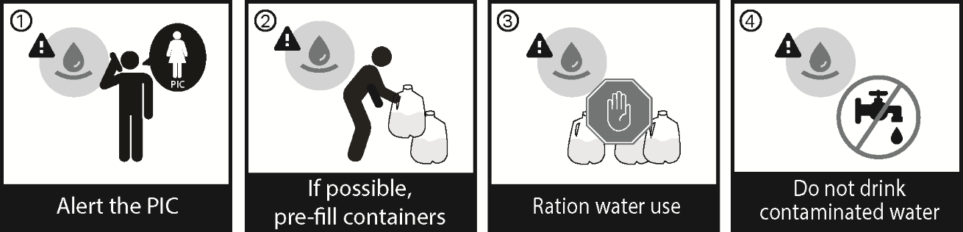

OVERVIEW
The facility’s domestic cold water supply is derived from one water supply line from the town/village/city of ___________.

Expected “potable” water usage under restricted use of water conditions is approximately ___________ gallons per day.

Additional non-potable (industrial) water supplies will be required for other building systems (e.g., boilers, toilets, HVAC, etc.).

GENERAL ACTIONS APPLICABLE TO ALL STAFF
- Do not drink water which is contaminated or suspected to be contaminated.
- If advanced notice is given, fill all containers and tubs with water.
- Services affected by loss of water:
- Hot water, hand washing, and resident care activities
- Laundry services
- Cooking, ice machines and dishwashing
- Fire suppression system (sprinklers)
- Water currently stored in facility (storage tanks, bottled water, etc.) will be rationed for use depending upon the following priority:

Priorities for the use of Available Water and Liquids | Location Obtained
1. Personal Consumption  (1-3 gallons per person per day). | Food Services: milk, soda, juice, bottled water – Outside Vendors
2. Personal Hygiene | SEE water loss contingency plans below.  (Non-potable water can be used to force flush toilets)
3. Cooking | SEE water loss contingency plans below.
4. Housekeeping / Clean up | SEE water loss contingency plans below.  (Non-potable water may be used to clean up spills or mop floors)

NOTE: If a “Contaminated Water Advisory” is issued, do not drink the water. If a “Boil Water” advisory or order is issued, there may be a need to sanitize the facility water supply system. Coordinate response and recovery efforts for Contamination of Water or Boil Water advisories with local public health, local water supplier and the state Department of Health.

INCIDENT COMMAND (ADMINISTRATOR OR PERSON IN CHARGE AT TIME)
- Consider activating the Command Center and assigning positions to manage the incident and ensure all other guidelines of this procedure are carried out. If not, all actions of the plan must be accomplished by on-duty administrative staff.
- As applicable, ensure a Contaminated Water Advisory is issued, staff and residents are notified. Consider posting information and utilizing Resident TV Channel ____ to keep staff and residents informed.
- Water from faucets should only be used for flushing toilets. It is not to be used for drinking, hand washing, or cooking. As applicable, place signage on drinking fountains, sinks and other areas.
- Request Department Rapid Assessment Forms be completed and returned to the Command Center.
- If loss of water supply to the fire suppression system, notify Fire Department and insurance carrier that the fire sprinkler system is out of service.
  - If fire sprinkler system is out of service for more than ten (10) hours, establish a “fire watch.” See Fire Watch procedure in the loss of Fire Protection procedure. Make appropriate notifications to ____.
- A list of potable and non-potable water supplies stored in the building is attached to this procedure, as well as vendors who can provide resupply.
- Determine ability to obtain potable water and non-potable water from outside sources. Contact vendors or others to determine if a water tanker can be provided to supply non-potable water for building operations.

DEPARTMENT-SPECIFIC ACTIONS

MAINTENANCE
- If contamination of the water supply is reported or suspected, shut down tap water to prevent anyone from drinking the water.
- If loss of water supply, contact Water Department and attempt to determine the extent and expected duration of the outage. Inform Administrator / Command Center.
  - Shut off main valves to prevent loss of water within piping.
  - Assist in obtaining stored water from within facility. Use food service containers to transfer water for consumption.
- If facility has received notification of a planned disruption of the water service, available containers (tubs, pots, sinks, etc.) should be filled prior to the shut-down.
- Check vacuum pumps, boiler water make-up, kitchen coolers/freezers, HVAC, steam sterilizers and the fire sprinkler system. Shut down, as necessary.
- Assess possible impact on water cooled heating/refrigeration systems and emergency generator. Shut down, if necessary.
- Turn off water heaters and boilers if water is going to be drained for other uses.
- Have Maintenance or plumber close all domestic water main valves.
- As necessary, obtain non-potable water tankers from vendors. Notify Fire Department and request one (1) pumper to respond. When water tanker responds from the vendor, use water tanker to supply the Fire Department pumper so a connection can be made to the Fire Department Connection (FDC) to supply the sprinkler system and/or standpipe connections.

DINING SERVICES
- Advise Command Center of water and other liquids available for consumption.
- Use disposable/paper dishes and utensils.
- Institute Emergency (non-cooking) Menu, as necessary.
- Shut down water cooled refrigeration units and transfer food items to units which are not water-cooled.
- Provision for an adequate and continuous supply of ice should be made at once. Contact outside vendor, as necessary.
- If loss of water is due to contamination, the Food Service dishwasher should be taken out of service, all ice machines should be emptied, including ice in the storage bins, and the water supply should be turned off.
- Coffee machines, soda and juice dispensers, and other appliances connected to the freshwater line should be turned off and valves closed.

CENTRAL SUPPLY
- Use gas sterilization, if available/possible.
- Consider using bottled water from an outside vendor to operate sterilizers if outage will be significant.
- Immediately arrange for the provision of potable drinking water.
- Check with clinical areas to see if you can help with water needs.

NURSING
- Restrict resident showers. Consider waterless bath products where applicable.
- Use waterless hand cleansers where possible.
- Use disposable swabs for oral care.
- Use disposable pads to reduce the need for linen changes.
- Disposable linens may be obtained from Central Supply and substituted depending on the expected duration of the water interruption.
- Use bottled water for oxygen humidifiers, vaporizers, etc.
- Use pre-mixed, pre-packaged enemas.
- If it is determined that the water supply has become contaminated, dispose of water at resident’s bedside. Replace with bottled water.
- Ensure alternate treatment areas for displaced dialysis residents.

HOUSEKEEPING
- Discontinue any routine cleaning that requires water. Use spray cleaners where necessary.
- As directed by Command Center, take containers of water for force flushing toilets to designated areas.
- If loss of water results from contamination of the water supply, all drinking fountains and hand-washing facilities should be turned off and labeled “Not Suitable to Drink or Wash In.”

LAUNDRY
- Provide a linen inventory to the Command Center.
- Coordinate a plan to reduce linen use with Nursing.
- Disposable linens may be obtained from __________________ and substituted depending on the expected duration of the water interruption.
- Investigate ability of vendors to supply linen.

SOURCES OF POTABLE WATER
Stored in the building
LOCATION | AMOUNT

Other sources of consumable liquid stored in the building
TYPE OF LIQUID | LOCATION | AMOUNT
Ice Machines
Juice
Milk
Soda

Vendors that can supply potable water
VENDOR | PHONE # | AMOUNT

SOURCES OF NON-POTABLE WATER
Stored in the building or on the campus
LOCATION | AMOUNT | METHOD TO ACCESS
Note: Indicate if there are any sources on or near the campus such as wells, streams, ponds, etc. where Non-potable water can be obtained.

Vendors that can supply non-potable water
VENDOR | PHONE | AMOUNT

RETURN TO NORMAL OPERATIONS / RECOVERY
If water loss was due to contamination, upon restoration of clean water:
- Have Maintenance ensure source of water contamination has been eliminated.
- Have Maintenance:
  - Flush all water lines and strainers, and clean faucet aerators, as necessary.
  - For ice machines: Change in-line filters; clean and disinfect hoppers/bins and storage bins; discard the first batch of ice.
  - For coffee machines, soda and juice dispensers and other appliances connected to the freshwater line: change the in-line filters; cycle 3 times before dispensing drinks.
  - For dishwashers: Run empty dishwasher for full cycle; change in-line filters; clean and disinfect interior of unit.

If water loss was due to any other cause, upon restoration of water:
- Have Maintenance check sprinkler system to ensure that no damage has occurred as a result of the disaster before water service is restored.
- Get clearance from Public Health Authorities, as applicable.
- Collect cost for reimbursement, as necessary, and develop a full report for critique.
- Have Department Heads restock supplies, as needed.
- Close down Incident Command.
- Critique reports and make necessary updates.

ADDITIONAL REFERENCES:
Loss of Sewer/Waste System Procedure
Emergency Utility Shut-Off Locations
Emergency Contractor/Vendor List
LOSS OF WATER SERVICE DURING DIALYSIS

DIALYSIS STAFF

The Dialysis proportioning machine requires a constant supply of incoming water. If the water supply is interrupted during the dialysis procedure, the following measures should be taken:

- The water pressure light will illuminate.
  - Check to see that the water faucet is open.
  - Check to see that incoming water line is patent and not blocked.
  - If the above items are satisfactory, then dialysis can continue for up to 20 minutes in bypass.

- To Remove Resident from Dialysis
- Turn off blood pump.
- Clamp arterial and venous tubing coming from machine.
- Clamp arterial and venous tubing coming from patient.
- Disconnect the lines, maintaining sterility of the ends if possible. Place caps on ends of lines.
- Attach saline syringes to both arterial and venous tubing from patient and flush, if able.
- If unable to flush line, obtain other vascular access for saline replacement.
- Check to see when water supply will be restored. If the interruption is for the whole day, patients should be rescheduled appropriately. In the event that the dialysis unit is unable to provide services to patients due to extended unit shut-downs, defined as greater than 24 hours, the following facilities should be notified for assistance:
    - _____________________________ Phone: _______________
    - _____________________________ Phone: _______________
    - _____________________________ Phone: _______________

Insert areas/locations in facility that are prone to flooding
Revise position title, if necessary
Delete paragraph if no elevators
Revise position title, if necessary
Revise department name if necessary
Delete if not applicable
Populate list as appropriate
Revise position title if necessary
Revise position title if necessary
Revise position title if necessary
Revise position title if necessary
Revise position title if necessary
Insert code or delete reference to code word if none being used
Revise position title if necessary
Insert locations where Safety Data Sheets are located in the facility
Insert locations where the list of spill cleanup items can be found
Revise list of spill cleanup items as necessary
Revise position title if necessary
Revise position title if necessary
Revise position title if necessary
Insert name and phone number of contracted spill cleanup company
Revise position title if necessary
Revise position title if necessary
Amend to reflect facility policy
Insert who should be notified (e.g., Administrator)
Revise as necessary
Insert code word or delete reference
Revise position title if necessary. Insert security if appropriate.
Revise position title if necessary.
Revise as necessary to reflect type of gas
Revise position title if necessary
Revise position title if necessary
Revise position title if necessary. Insert security if appropriate.
Revise position title if necessary
Revise position title if necessary
Revise as necessary
Delete if none exists in the facility
Revise position title if necessary
Revise as necessary
Delete Procedure if not at risk from the effects of a hurricane
Determine appropriate time frame for your facility and revise as necessary throughout this procedure. A minimum of 3 days is recommended
Determine appropriate time frame for your facility and revise as necessary throughout this procedure. A minimum of 3 days is recommended
Determine an appropriate time frame for your facility and revise as necessary throughout this procedure. A minimum of 3 days is recommended
Delete if not applicable
Revise list to reflect devices used
Typically used for Continuing Care Communities with IL/AL and SNF residents. Revise, as necessary.
Determine appropriate time frame for your facility and revise as necessary throughout this procedure. A minimum of 3 days is recommended
Revise position title if necessary
Determine appropriate time frame for your facility and revise as necessary throughout this procedure. A minimum of 3 days is recommended
Revise position title if necessary
Determine appropriate time frame for your facility and revise as necessary throughout this procedure. A minimum of 3 days is recommended
Determine appropriate time frame for your facility and revise as necessary throughout this procedure. A minimum of 3 days is recommended
Determine appropriate time frame for your facility and revise as necessary throughout this procedure. A minimum of 3 days is recommended
Determine appropriate time frame for your facility and revise as necessary throughout this procedure. A minimum of 3 days is recommended
Determine appropriate time frame for your facility and revise as necessary throughout this procedure. A minimum of 3 days is recommended
Revise position title if necessary
Determine appropriate time frame for your facility and revise as necessary throughout this procedure. A minimum of 3 days is recommended
Determine appropriate time frame for your facility and revise as necessary throughout this procedure. A minimum of 3 days is recommended
Revise position title if necessary
Determine appropriate time frame for your facility and revise as necessary throughout this procedure. A minimum of 3 days is recommended
Determine appropriate time frame for your facility and revise as necessary throughout this procedure. A minimum of 3 days is recommended
Revise position title if necessary
Determine appropriate time frame for your facility and revise as necessary throughout this procedure. A minimum of 3 days is recommended
Determine appropriate time frame for your facility and revise as necessary throughout this procedure. A minimum of 3 days is recommended
Revise as applicable
Determine appropriate time frame for your facility and revise as necessary throughout this procedure. A minimum of 3 days is recommended
Revise, as necessary. If no security assign responsibilities to another department such as maintenance
Determine appropriate time frame for your facility and revise as necessary throughout this procedure. A minimum of 3 days is recommended
Determine appropriate time frame for your facility and revise as necessary throughout this procedure. A minimum of 3 days is recommended
Determine appropriate time frame for your facility and revise as necessary throughout this procedure. A minimum of 3 days is recommended
Determine appropriate time frame for your facility and revise as necessary throughout this procedure. A minimum of 3 days is recommended
Revise to reflect what is in use in the facility
Revise position titles, if necessary, delete security if none
Revise as necessary
Delete if no elevators
Determine appropriate time frame for your facility and revise as necessary throughout this procedure. A minimum of 3 days is recommended
Revise position title if necessary
Revise as necessary
Revise position title if necessary
Revise if using a different code word
Revise to reflect locations within your facility
Insert name of regulatory agency
Insert who should be notified
Revise position title if necessary
Revise position title if necessary
Insert vendor information
Revise position title if necessary
Revise position title if necessary
Revise position title if necessary
Revise department name if necessary
Revise department name if necessary
Revise amount per facility supply
Delete if not applicable
Revise list to reflect what is available in your facility
Revise as necessary
Insert how to access kitchen and food supply 24/7
Insert location of stored emergency food supply
Complete for each listed diet as necessary, for three days. Insert existing menus that may already exist.
Insert location
Complete for each listed diet as necessary, for three days
Insert location
Complete for each listed diet as necessary, for three days
Insert location
Complete for each listed diet as necessary, for three days
Insert location
Insert generator location, size, fuel type, etc.
Revise position title if necessary
Revise position title if necessary
Revise position title if necessary
Revise as necessary
Revise position title if necessary
Insert activation code word if the facility utilizes one for the loss of power.
Delete if not applicable
Insert regulatory agency
Revise position title, if necessary
Insert electric company name and phone #
Revise equipment list, as necessary
Revise as necessary
Revise as necessary
Revise as necessary
Revise position title if necessary
Revise paragraph to reflect your facility operations if necessary
Revise to reflect services and care levels provided. Delete if not applicable
Revise position title if necessary
Delete if not applicable
Delete this part of the procedure if not applicable
Validate the following emergency procedure with Dialysis staff, revise as necessary
Insert time frame
Insert activation code
Revise if a single-story building
Delete if no elevators
Insert name of regulatory agency
Revise as necessary to reflect proper levels of care and services provided
Delete if not applicable
Revise position title if necessary
Validate with maintenance staff
Delete if no elevators
Revise position title, if necessary
Delete procedure if no elevators
Revise position title if necessary
Revise department name if necessary
Revise department name if necessary
Revise statement to reflect buildings fire alarm system
Revise as necessary
Revise position title if necessary
Revise position title if necessary
Insert FD information
Revise if different than Code Red
Insert additional individuals or agencies if any
Revise position title if necessary
Insert regulatory agency name
Revise position title if necessary
Revise position title if necessary
Insert additional individuals or agencies if any
Revise if Authority Having Jurisdiction has a different requirement
Insert Regulatory Agency name
Revise as necessary
Revise position title if necessary
Revise to reflect building heating systems in use
Revise position title if necessary
Revise as necessary
Delete if not practical
Revise department name if necessary
Revise department name necessary
Revise department name if necessary
Revise position title if necessary
Revise as necessary
Revise as necessary
Revise as necessary
Revise list of services to be restored as priority with IT staff
Revise position title, if necessary
Revise as necessary
Revise position title, if necessary
Revise position title, if necessary
Revise position title, if necessary
Revise if no Electronic Health Records
Delete if no automated medication dispensing machines
Delete if no pharmacy or medication dispensing location
Revise position title, if necessary
Revise to reflect type of gas in use. If no gas services in the building or any appliances, delete procedure.
Revise to reflect type of gas in use.
Revise to reflect type of gas in use. List all services and appliances dependent upon gas.
Insert regulatory agency name
Revise department name, if necessary
List cooking appliance served by gas
Revise position title, if necessary
Revise as necessary
Delete if no in-house laundry department
Revise to reflect type of gas in use.
Revise position title, if necessary.
Revise to reflect type of gas in use.
Revise position title, if necessary.
Delete procedure if no centralized, piped Medical Gas system in the building
Revise position titles, if necessary
Revise position title, if necessary
Revise position title, if necessary
Insert storage location
Revise position title, if necessary
Insert location
Insert location of oxygen quick connection
Insert location
Revise as necessary
Insert name of regulatory agency
Revise position title, if necessary
Revise position title, if necessary
Insert location of non-potable water source such as boiler tank water, nearby pond or stream, well, etc.
Revise position title, if necessary
Revise position title, if necessary
Revise position title, if necessary
Revise position title, if necessary
Delete if no steam in the building
List services or appliances dependent upon a supply of steam
Revise position title, if necessary
Revise position title, if necessary
Revise as necessary
Revise position title, if necessary
Delete if no sterilization process at facility
Revise position title, if necessary
Revise position title, if necessary
Insert safeguards in place such as UPS battery back-up, power fail phones, redundant POTS lines, etc.
Revise to reflect what will be utilized in your facility
Revise position title, if necessary
Delete if no radios
Insert storage location.
Revise position title, if necessary
Delete if no such system exists in your building
Revise position title, if necessary. Delete security if none and assign responsibility to another position
Populate list with phones and numbers that are separate from your internal phone system.
Delete if none
Delete if none
List only if separate from internal phone system
Revise position title, if necessary
Insert number of water supply lines servicing the building
Insert expected number of gallons to be used on a daily basis for staff, residents and visitors. 1 gallon per person per day x 3 days is considered a minimum.(e.g.: 100 residents and staff = 100 gallons per x 3 days = 300 gallons of water)
Revise list, as necessary
Revise position title, if necessary
Revise as necessary, delete if no resident TV channel for informational purposes
Insert regulatory agency name
Revise position title, if necessary
Revise as necessary
Revise as necessary
Revise position title, if necessary
Revise position title, if necessary
Delete if not applicable
Revise as necessary
Delete if not applicable
Revise position title, if necessary
Delete if none
Delete if no in-house laundry services
Insert location if applicable
Insert sources of stored “potable” water and other liquid sources in the building. Include gallons in hot water storage tanks
Insert vendor information for those that can provide bottled or bulk potable water
Insert sources of stored “non-potable” water in the building and on the campus. Include pools, wells, ponds, streams, boiler tanks, etc.
Insert vendor information that can provide non-potable water, typically bulk tanker water that can be used for building operations and/or the fire suppression system
Revise position title, if necessary
Revise position title, if necessary
Revise as necessary
Revise position title, if necessary
Delete if not applicable
Validate procedure with Dialysis staff

